**Low Level Design**

**Content:**

**OOPs**

**Association**

**a) Aggregation**

**b) Composition**

**UML Diagram**

**Class Diagram**

**Sequence Diagram**

**Use Case Diagram**

**Activity Diagram**

**Design Principles:**

* + - * **Solid Principles**
      * **DRY**
      * **YAGNI**
      * **KISS**

**Design patterns**

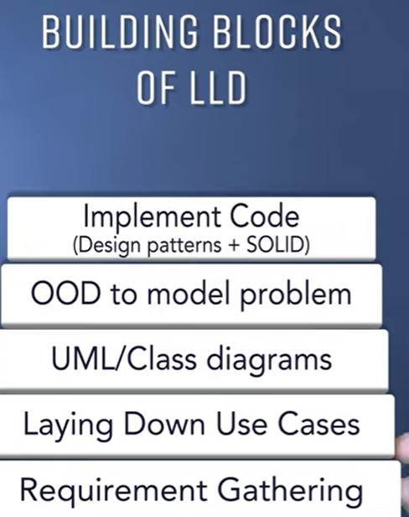

**Introduction**

Classes as individual entities( without any relations between them ) are impractical in object-oriented programming because then we would not be able to model the relationships that exist between real-life entities.

A student is called a student because he studies in a school/college. Here both student and college entities can be modeled as two individual classes with a relation of client-provider (wherein college “provides” education to the student) between them. Similarly, there would be no concept of the employee in real life without the existence of an organization that employs individuals, thus an organization is associated with an employee(here the relation is ‘employment’).

Here the Employee and Organization can be modeled as two distinct classes in OOPS with a relation of employment. So understanding how these associations work in object-oriented programming is something every programmer must be aware of, which we shall cover in the further sections of this article.

**Association in Java**

Association, in general terms, refers to the relationship between any two entities. Association in java is the relationship that can be established between any two classes. These relationships can be of four types:

1. One-to-One relation
2. One-to-many relation
3. Many-to-one relation
4. Many-to-many relation

To illustrate, let’s take two classes, Professor class, and Department class. Below are the type of relationships/associations that can be possible between them

* One professor can only be assigned to work in one department. This forms a **one-to-one** association between the two classes.
* One professor can be assigned to work in multiple departments. This is a **one-to-many** association between the two classes.
* Multiple professors can be assigned to work in one department. This forms a **many-to-one** association between the two classes.
* Multiple professors can be assigned to work in multiple departments. This is the **many-to-many** association between the two classes.

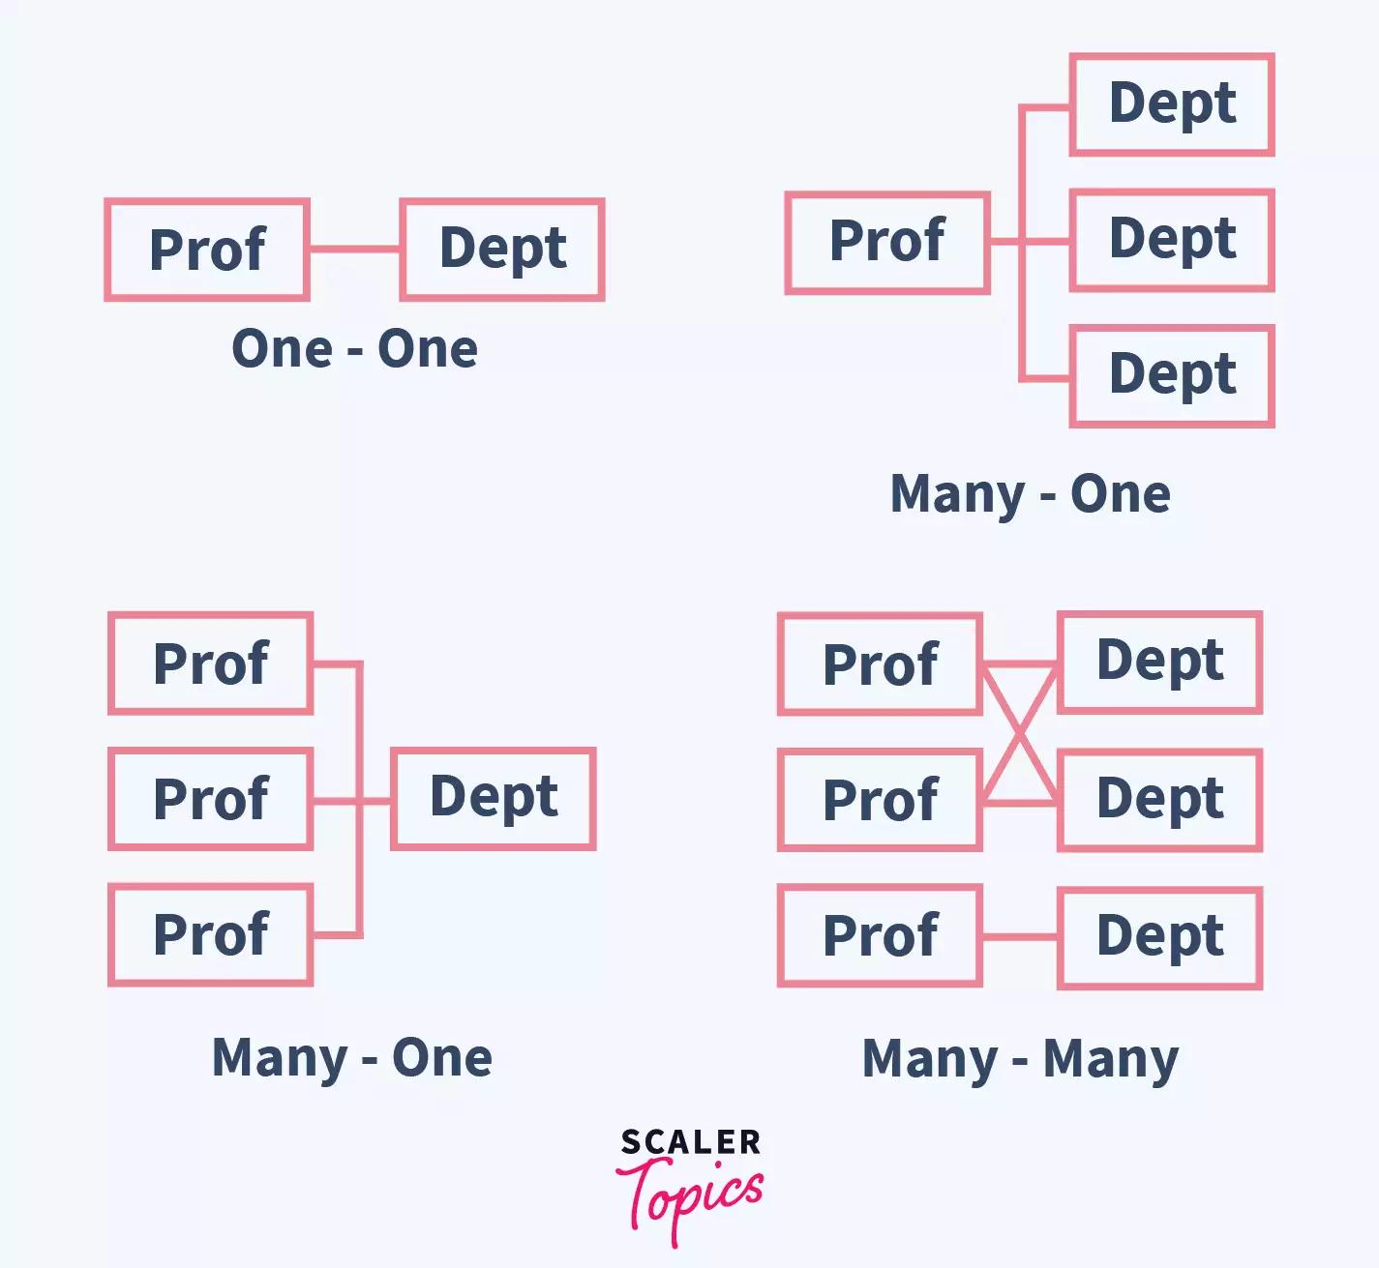

These associations in java help the objects of one class to communicate with the objects of the other class.

* So one object will be able to access the data of another object. For example, A professor entity modeled as an object would be able to access/know the names of all the departments he works at. And a department object can be able to access/know the names/details of all the professors that work in it.
* Functionality/Services of one object can be accessible to another object. For example, A professor who is trying to enroll in a department can be able to verify whether a department he wants to join has a vacancy. This service(programmatic method/function) to find whether there’s a departmental vacancy can be provided by the Department class which the Professor class can access.

**Example program to illustrate one-to-many Association between Department class and Professor class in Java:**

import java.util.*;

//Professor Class

class Professor {

 private String name;

 //Assign professor name

 Professor(String name)

 {

   this.name = name;

 }

 //Retrieve name

 public String getName()

 {

   return this.name;

 }

}

//Department Class

class Department {

 private String name;

 List<Professor> staff;

 //Assign department name

 Department(String name)

 {

   this.name = name;

 }

 //Retrieve name

 public String getName()

 {

   return this.name;

 }

 //Assign list of department staff

 public void setStaff(List<Professor> staff)

 {

   this.staff = staff;

 }

 //Return the list of staff names

 public List<String> getStaff()

 {

   List<String> professor_names = new ArrayList<String>();

   for(Professor prof : this.staff)

   {

     professor_names.add(prof.getName()); //add name of each professor to names list

   }

   return professor_names; // return names list

 }

}

class Main {

 public static void main(String[] args) {

   //Create two professor objects

    Professor ak = new Professor("Arun Kumar");

    Professor ry = new Professor("Rahul Yadav");

    //Create a department

    Department cse = new Department("CSE");

    //Add the professors to a list and add this list to department

    List<Professor> staff_cse = new ArrayList<Professor>();

    staff_cse.add(ak);

    staff_cse.add(ry);

    //Add staff to cse department

    cse.setStaff(staff_cse);

    //Output

    System.out.println("The staff of department " + cse.getName() + " is: " + cse.getStaff());

 }

}

Output:

The staff of department CSE is: [Arun Kumar, Rahul Yadav]

**Explanation:**

The program is quite simple and straightforward. Below is a detailed explanation of how this works:

* The program has three classes
  + Main: Where objects are created and actual program functionality is written
  + Professor: Has the variables and methods related to professor class
  + Department: Has the variables and methods related to department class
* In the Professor Class, We have defined a variable name to store the name of the professor, and we wrote a constructor Professor() that assigns the name of the professor during object creation and a method getName() to fetch the name of the professor.
* In the Department Class, we have defined a variable name to store the name of the department and a list of staff to store the list of Professor objects( professors that are working in the department ). We wrote a constructor Department() that assigns the name of the department during object creation and three methods. One is getName()to fetch the name of the department. Two is setStaff() to store the list of staff(professor) objects and Three is getStaff() to fetch the list of staff/professor names (professors that are working in the department)
* In Main class we wrote the implementation
  + Created two objects for Professor class and one object for Department class
  + Next, create a list to store the objects of type Professor,
  + Add the two newly created objects of type Professor to the list. The objects were assigned names “Arun Kumar” & “Rahul Yadav” at their time of creation.
  + The department name is assigned as “CSE”
  + Add the created staff list to CSE department using setStaff() method;
  + Display the stored variables of department name and the list of names of department staff as output.

The classes Professor and Department are meaningfully interacting with each other, which determines their association. And the relation type here is one-to-many, as one department is related to multiple professors.

**Forms of Association in Java**

Before we dive into the forms of Association in java, let us briefly explore the types of object relationships that can exist in OOPs. There can be two types of relationships in OOPs:

* IS-A
* HAS-A

**1. IS-A (Inheritance)**

The IS-A relationship is nothing but Inheritance. The relationships that can be established between classes using the concept of inheritance are called IS-A relations.

Ex: A parrot is-a Bird. Here Bird is a base class, and Parrot is a derived class, Parrot class inherits all the properties and attributes & methods (other than those that are private) of base class Bird, thus establishing inheritance(IS-A) relation between the two classes.

The HAS-A association on the other hand is where the Instance variables of a class refer to objects of another class. In other words, one class stores the objects of another class as its instance variables thereby establishing a HAS-A association between the two classes.

**2. HAS-A (association)**

Note: The example program for the association we have discussed in the above section is a HAS-A association.Because Department class is storing the objects of Professor class as its instance variable staff ( the Listwhich is storing a list of Professors class objects). And a Department class object can access these stored Professor objects to store/retrieve information from Professor Class, thereby creating an association between the two classes.

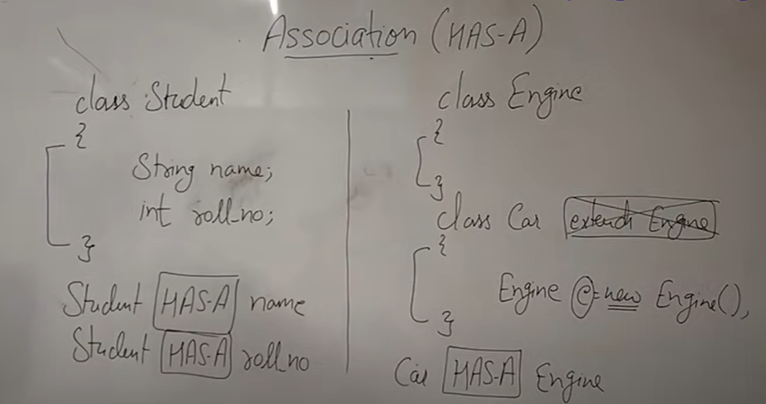

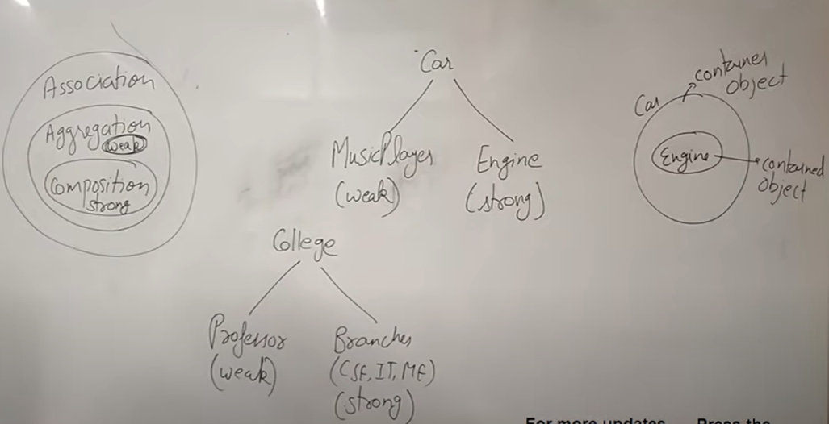

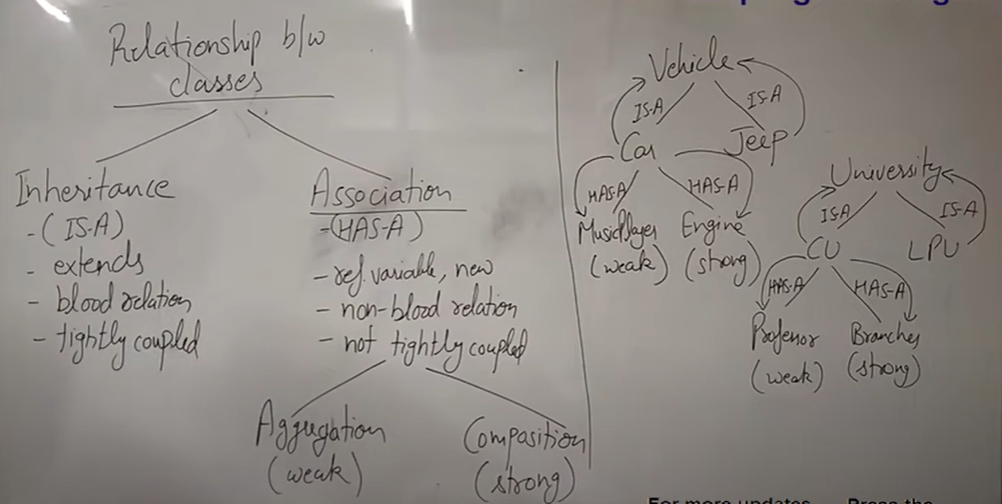

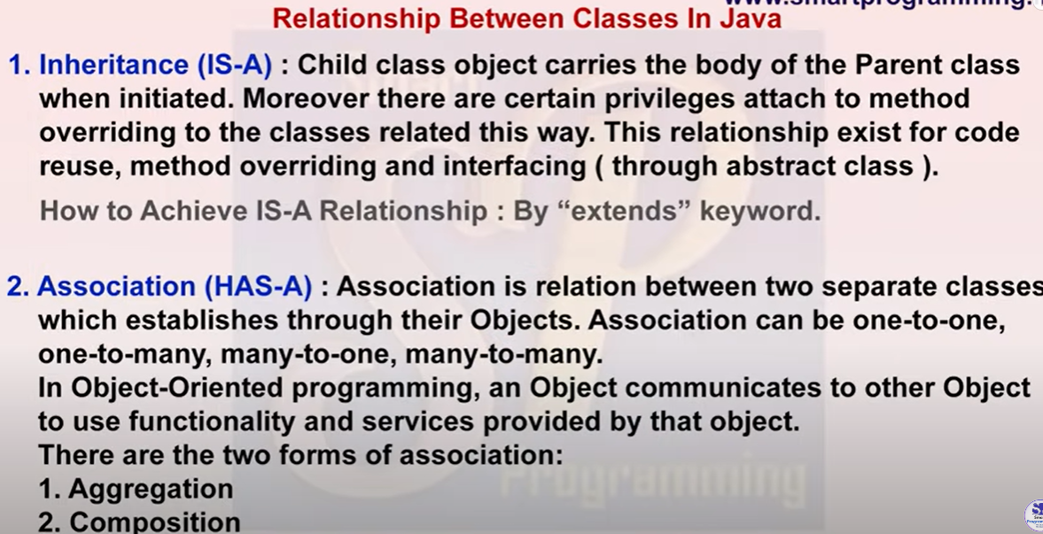

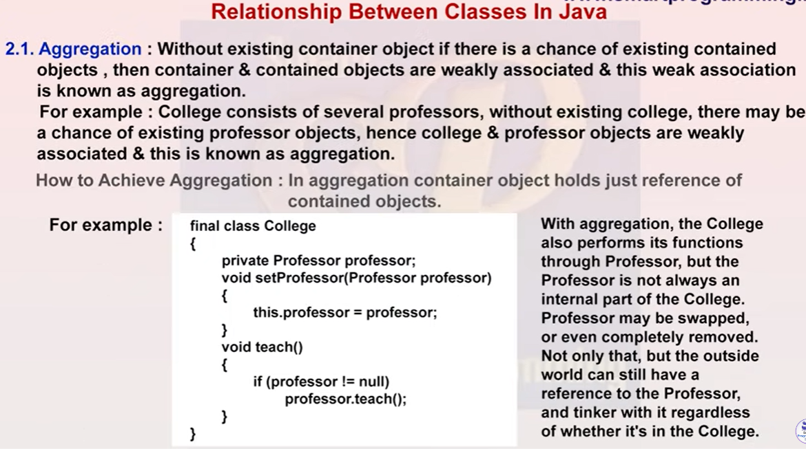

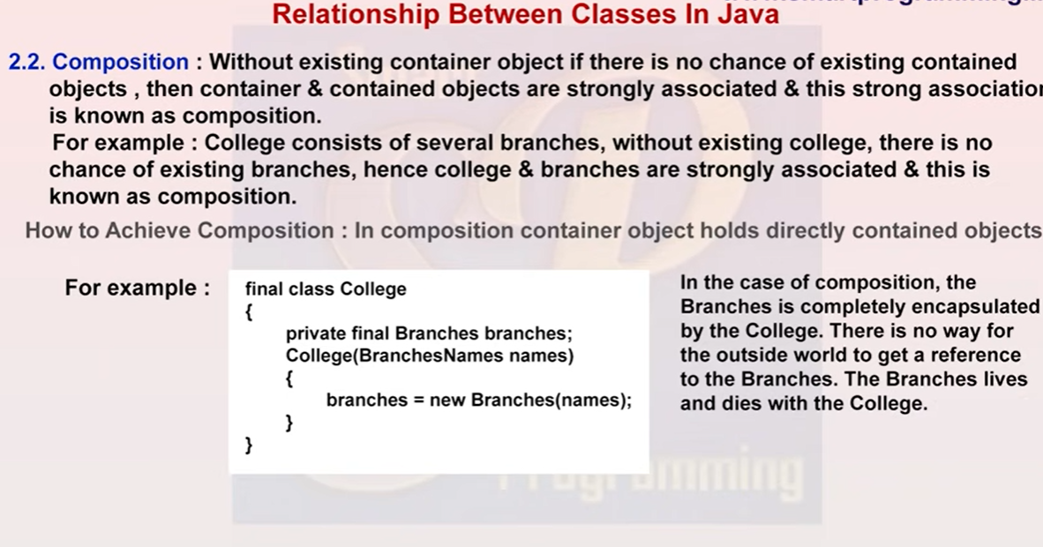

**There are two forms of Association that are possible in Java:**

**a) Aggregation**

**b) Composition**

**Aggregation:**

Aggregation in java is a form of HAS-A relationship between two classes. It is a relatively more loosely coupled relation than composition in that, although both classes are associated with each other, one can exist without the other independently. So Aggregation in java is also called a weak association. Let us look at a simple aggregation example to understand this better.

**Example**: Consider the association between a Country class and a Sportsperson class. Here’s how it is defined

* Country class is defined with a name and other attributes like size, population, capital, etc, and a list of all the Sportspersons that come from it.
* A Sportsperson class is defined with a name and other attributes like age, height, weight, etc.

In a real-world context, we can infer an association between a country and a sports person that hails from that country. Modeling this relation to OOPs, a Country object has-a list of Sportsperson objects that are related to it. Note that a sportsperson object can exist with his own attributes and methods, alone without the association with the country object. Similarly, a country object can exist independently without any association to a sportsperson object. In, other words both Country and Sportsperson classes are independent although there is an association between them. Hence Aggregation is also known as a weak association.

Another point to note is that here, the Country object has-a Sportsperson object and not the other way around, meaning the Country object instance variables store the Sportsperson objects(This will be clear when we look at the java program in the next section), so the association is one-sided. Thus Aggregation is also known as a unidirectional association.

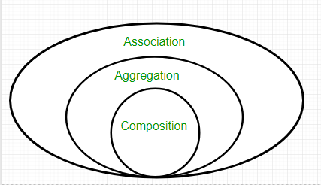

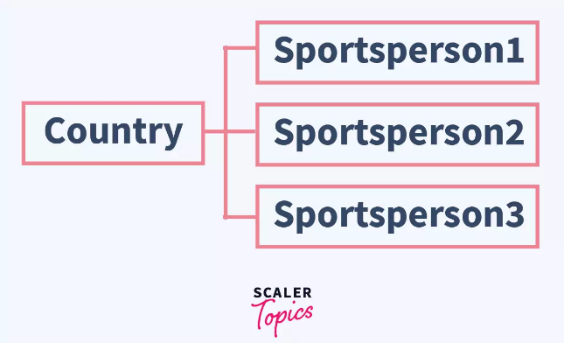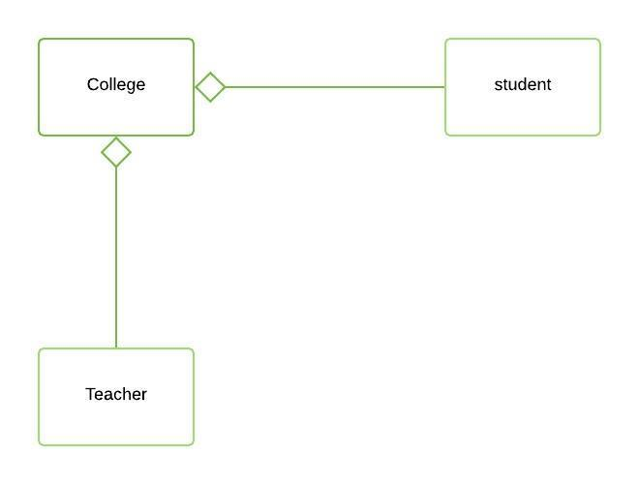

**Refer:**

<https://www.geeksforgeeks.org/association-composition-aggregation-java/>

**Program:**

import java.util.*;

//Country class

class Country{

private String name;

List<SportPerson> sportPersons;

  public Country(String name)  //to assign Country name

  {

    this.name = name;

  }

public void setSportPersons(List<SportPerson> sportPersons)  //To assign sportspeople

{

    this.sportPersons = sportPersons;

}

public List<String> getSportPersons()

{

  List<SportPerson> listOfSportPersons = this.sportPersons;

  List<String> names = new ArrayList<String>();

  for(SportPerson sportPerson : listOfSportPersons)

  {

      names.add(sportPerson.getName());

  }

  return names;

}

 public String getName()

 {

  return this.name;

 }

}

//Sportsperson class

class SportPerson{

private String name;

 public SportPerson(String name)  //to assign Sportsperson name

{

  this.name = name;

}

public String getName()

{

  return this.name;

}

}

class Main {

public static void main(String[] args) {

  //Create three Sportsperson objects

  SportPerson macculum = new SportPerson("Mccullum");

  SportPerson dhoni = new SportPerson("Dhoni");

  SportPersonk kohli = new SportPerson("Kohli");

  //Create a country

  Country india = new Country("India");

  //Create a arraylist and add the sportspersons

  List<SportPerson> listOfSportPersons = new ArrayList<SportPerson>();

  sportPersons.add(macculum);

  sportPersons.add(dhoni);

  sportPersons.add(kohli);

  //now add this list to Country Class

  india.setSportPersons(listOfSportPersons);

  //Outputting the Has-a association between Country and Sportsperson

  System.out.println("The sports people from country " + india.getName() + " are " + india.getSportPersons());

}

}

Output:

The sports people from country India are [Macculum, Dhoni, Kohli]

**Explanation:**

* A Country class is defined with a variable to store its name and another list of “sportPersons” variable to store the objects of SportPerson.
* A constructor is defined in Country class to assign the name of the country during object creation
* Three methods getSportPersons() and setSportPersons() and getName() are defined to set or get the list of sportspersons and to get the name of the country.
* A SportPerson class is defined with a variable name to store its name and a constructor to assign the name during object creation
* A method getName() is defined in the SportPerson class to get the name of the sportsperson.
* The implementation in the Main class is pretty straightforward. Three SportPerson objects are created and a Country object is created. All the three SportPerson objects are added to the newly created list.
* This is the logical idea behind Aggregation, Sportsperson Class objects can exist independently of the Country class object.
* if Country object is to be deleted, it has no effect on the SportPerson and vice-versa.
* Thus Aggregation helps in code reusability. Since classes exist independently, The same classes can be reused to create associations with other classes, without having to modify an existing class, or without causing any issues to existing associations.

**Composition:**

Composition in java is a form of relation that is more tightly coupled. Composition in java is also called Strong association. This association is also known as Belongs-To association as one class, for all intents and purpose belongs to another class, and exists because of it. In a Composition association, the classes cannot exist independent of each other. If the larger class which holds the objects of the smaller class is removed, it also means logically the smaller class cannot exist. Let us explore this association clearly with an example

**Example**: The association between College and Student. Below is how it is defined.

* College class is defined with name and the list of students that are studying in it
* A Student class is defined with name and the college he is studying at.

Here a student must be studying in at least one college if he is to be called Student. If the college class is removed, Student class cannot exist alone logically, because if a person is not studying in any college then he is not a student.

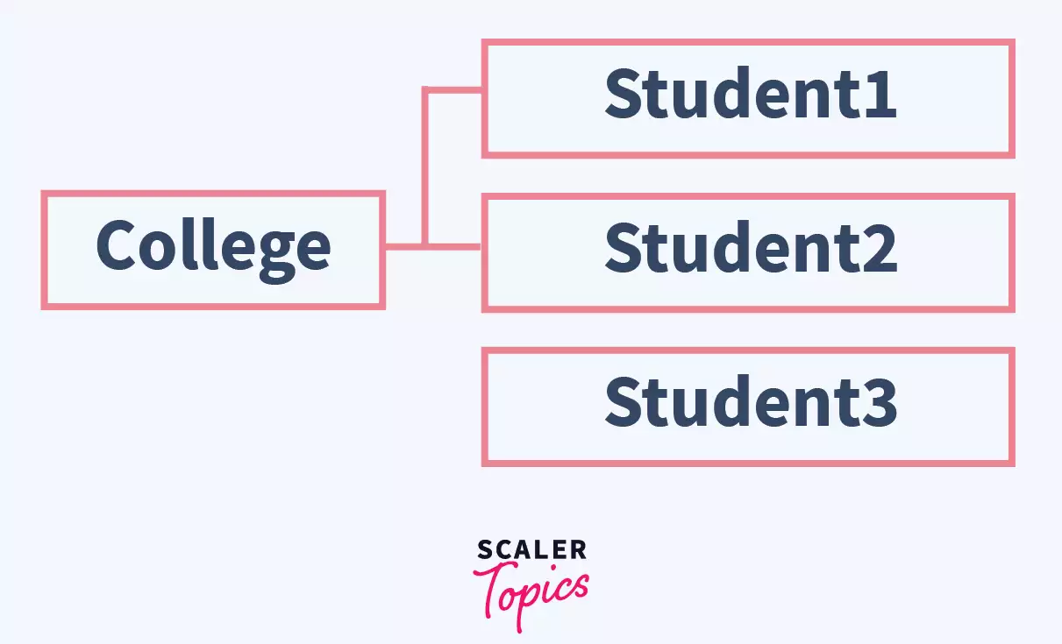

import java.util.*;

//College class

class College{

private String name;

ArrayList<Student> studentList;

public College(String name)  //to assign college name

{

   this.name = name;

}

public void setStudentList()  //To set Students list

{

    //Create three Student objects

    Student student1 = new Student("Abe");

    Student student2 = new Student("lincoln");

    Student student3 = new Student("Abraham");

    ArrayList<Student> students = new ArrayList<Student>();

    students.add(student1);

    students.add(student2);

    students.add(student3);

    this.studentList = students;

}

public String getName()

{

  return this.name;

}

public List<String> getStudentList() //To get students list

{

 List<Student> students = this.studentList;

 List<String> names = new ArrayList<String>();

 for(Student student : students)

 {

     names.add(student.getName());

 }

 return names;

}

}

//Student class

class Student{

private String name;

 public Student(String name)  //to assign Student name

{

  this.name = name;

}

public String getName()

{

  return this.name;

}

}

class Main {

public static void main(String[] args) {

 //Create a College

 College college1 = new College("MIB");

 //set Student List in College Class

 college1.setStudentList();

 //Outputting the Has-a association between College and Student

 System.out.println("The students studying in " + college1.getName() + " college are " + college1.getStudentList());

}

}

Output:

The students studying in MIB college are [Abe, lincoln, Abraham]

**Explanation:**

* Student class is defined with name and constructor to set the name during object creation
* A method getName is defined in Student class to get the name of the student
* College class is defined with name and list of students that are studying in it.
* A constructor in College class is defined to set the name of the college during the object creation. A method getName is defined to get the name of the college and getStudentList is defined to get the names of the students studying in that college.
* The method setStudentList is defined, which created three students’ objects inside the College class and assigned them to the college studentList.So here, the Student class objects are created and stored internally in the College class, which creates a tightly bound association between the College and Student classes. Because, if College class is removed, all student objects are removed as well.
* All the students are to be part of the class, no student can exist independently. And the result is outputted.
* Note here that no single student can exist without a college, but a college can exist without the student. Student is the dependent class.

**Difference between association, aggregation, composition in Java**

Association in java is one of the types of relations between classes. It has two forms Aggregation(HAS-A) and Composition(Belongs-to). Aggregation is a relatively weak association, whereas Composition is a strong association. Composition can be called a more restricted form of Aggregation. Aggregation can be called the superset of Composition, since all Compositions can are Aggregations but, not all Aggregations can be called Composition.

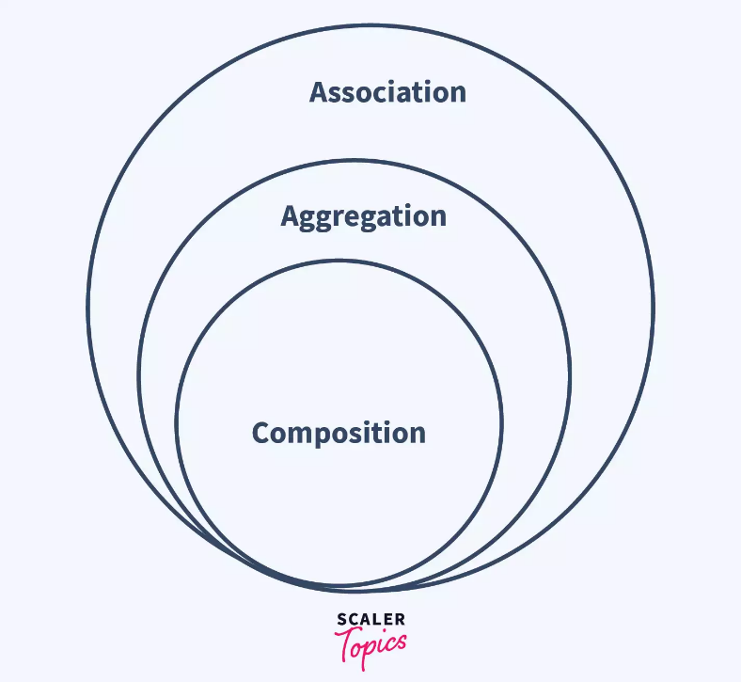

**Below are the primary differences between the forms of Association, Composition and Aggregation in java:**

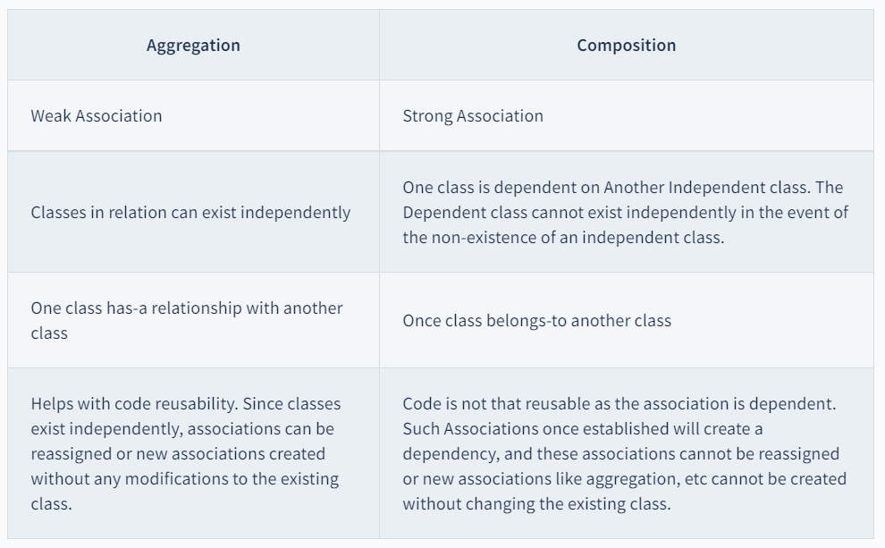

**OR**

| **Aggregation** | **Composition** |
| --- | --- |
| Weak Association | Strong Association |
| Classes in relation can exist independently | One class is dependent on Another Independent class. The Dependent class cannot exist independently in the event of the non-existence of an independent class. |
| One class has-a relationship with another class | Once class belongs-to another class |
| Helps with code reusability. Since classes exist independently, associations can be reassigned or new associations created without any modifications to the existing class. | Code is not that reusable as the association is dependent. Such Associations once established will create a dependency, and these associations cannot be reassigned or new associations like aggregation, etc cannot be created without changing the existing class. |

**Coding of Aggregation and composition**

<https://www.geeksforgeeks.org/association-composition-aggregation-java/>

# **Difference Between Aggregation and Composition in Java**

An object is a real-time entry, and objects have relationships between them both in programming or real life. Objects are related to each other using more than one relationship, such as Aggregation, Composition, Association, etc.

Let's understand the difference between Aggregation and Composition but before that we understand all these three relationships in detail.

## Composition

## 

Composition is a **"belong-to"** type of relationship in which one object is logically related with other objects. It is also referred to as **"has-a"** relationship. We can understand **has-a** or **belong-to** by using the following example:

A classroom belongs to a school, or we can say a school has a classroom. So, calling both of them is only a matter of point of view.

Composition is a strong type of **"has-a"** relationship because the containing object is its owner. So, objects are tightly coupled, which means if we delete the parent object, the child object will also get deleted with it.

Let's take an example to understand how we can implement the logic for the **Composition** relationship in Java:

**CompositionExample.java**

1. **import** java.util.*;
2. // create class for Office
3. **class** Office {
4. // declare variables for name and address
5. **public** String name;
6. **public** String address;
7. // initialize name and address variables using constructor
8. Office(String name, String address)
9. {
10. **this**.name = name;
11. **this**.address = address;
12. }
13. }
14. // Create a class for Company that has more than one Office.
15. **class** Company {
16. // declare variable for company name
17. **public** String name;
18. // declare a list of OfficeOffice that a Company has
19. **private** **final** List< Office Office> offices;
20. // initialize variable and list using constructor
21. Company(String name, List<Office> offices)
22. {
23. **this**.name = name;
24. **this**.offices = offices;
25. }
26. // create a getter function to return a list of office
27. **public** List<Office> getTotalOfficesOfCompany()
28. {
29. **return** offices;
30. }
31. }
32. // create class CompositionExample1 to understand Composition example
33. **class** CompositionExample {
34. // main() method start
35. **public** **static** **void** main(String[] args)
36. {
37. // create objects of Office class.
38. Office o1 = **new** Office("Google India Pvt. Ltd", "Banglore");
39. Office o2 = **new** Office("Google India Pvt. Ltd", "Gurgaon");
40. Office o3 = **new** Office("Google India Pvt. Ltd", "Hyderabad");
41. Office o4 = **new** Office("Google India Pvt. Ltd", "Mumbai");
42. // create list which contains the no. of offices
43. List<Office> offices = **new** ArrayList<Office>();
44. offices.add(o1);
45. offices.add(o2);
46. offices.add(o3);
47. offices.add(o4);
48. // create an instance of the Company class by passing a list of Office to the constructor
49. Company company = **new** Company("Google", offices);
50. System.out.println(company.name+" offices:");
51. // get total offices of the Company using getter
52. List<Office> data = company.getTotalOfficesOfCompany();
53. // iterate offices of the company
54. **for** (Office office : data) {
55. // print data
56. System.out.println("Name : " + office.name + " and "+ " Address : " + office.address);
57. }
58. }
59. }

**Output:**

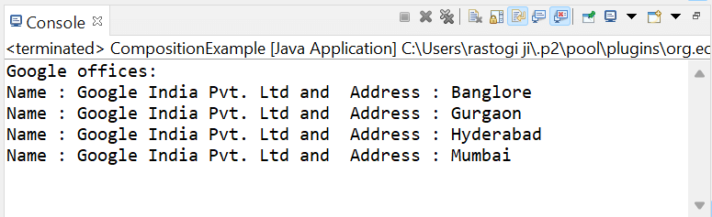

## Aggregation

Aggregation relationship is also a **"has-a"** relationship. The only difference between Aggregation and Composition is that in Aggregation, objects are not tightly coupled or don't involve owning. All the objects are independent of each other and can exist even if the parent object gets deleted. Let's understand this by using the following example:

A car comes with a wheel, and if we take off its wheels, the wheels will still exist. But a car without wheels won't be as useful as a car with its wheels, and that's how this relationship existed in the first place for assembling **the parts to a bigger construct, which is capable of more things than its parts**.

Let's take an example to understand how we can implement the logic for the **Aggregation** relationship in Java:

**Address.java**

1. // create class Address that have fields street, city, state, zip, and country
2. **public** **class** Address {
3. String city,state,country, zip, street;
4. // initialize Address using constructor
5. **public** Address(String street, String city, String state, String zip, String country) {
6. **this**.city = city;
7. **this**.state = state;
8. **this**.country = country;
9. **this**.street = street;
10. **this**.zip = zip;
11. }
12. }

**AggregationExample.java**

1. // create AggregationExample class to understand Aggregation concept
2. **public** **class** AggregationExample {
3. // declare variables
4. **int** empId;
5. String empName;
6. Address empAddress;
8. // initialize variables using constructor
9. **public** AggregationExample(**int** empId, String empName, Address empAddress) {
10. **this**.empId = empId;
11. **this**.empName = empName;
12. **this**.empAddress = empAddress;
13. }
14. // create display() method for showing data
15. **void** display(){
16. System.out.println("Employee Id: "+empId);
17. System.out.println("Employee Name: "+empName);
18. System.out.println("Address: "+empAddress.street+""+empAddress.city+" "+empAddress.state+" "+empAddress.zip+" "+empAddress.country);
19. }
20. // main() method start
21. **public** **static** **void** main(String[] args) {
22. // create objects of Address class
23. Address add1 = **new** Address("15205 North Kierland Blvd. Suite 100","Scottsdale","AZ", "85254", "America");
24. Address add2 = **new** Address("2829 Ala Kalanikaumaka, Kukui'ula Village", "Koloa","HI", "96756", "America");
26. // create object of AggregationExample by passing value to the constructor
27. AggregationExample employee1 = **new** AggregationExample(001, "Lucy", add1);
28. AggregationExample employee2 = **new** AggregationExample(002, "Paul", add2);
29. // show data to the users
30. employee1.display();
31. employee2.display();
33. }

**Output:**

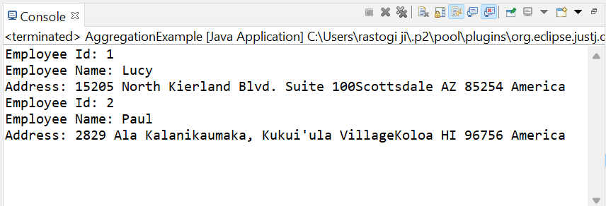

## Association

Association is not a **has-a** relationship and the weakest relationship among all. In an Association relationship, none of the objects are parts or members of another. A simple example of Association is a mother and her child.

Let's take an example to understand how we can implement the logic for **Association** relationships in Java:

**AssociationExample.java**

1. **import** java.util.*;
2. // create class Car a Person can have
3. **class** Car {
4. // declare variables for Car brand, color and modal
5. **public** String name, color, modal;
6. // getter and setter for initializing variables
7. **public** String getName() {
8. **return** name;
9. }
10. **public** String getColor() {
11. **return** color;
12. }
13. **public** String getModal() {
14. **return** modal;
15. }
16. **public** **void** setName(String name) {
17. **this**.name = name;
18. }
19. **public** **void** setColor(String color) {
20. **this**.color = color;
21. }
22. **public** **void** setModal(String modal) {
23. **this**.modal = modal;
24. }
25. }
26. // create Person class
27. **class** Person {
28. // declare variables for Person class
29. **public** String name;
30. List<Car> cars;
31. // getter and setter for initializing variables
32. **public** **void** showName() {
33. System.out.println(**this**.name+" has following cars:");
34. }
35. **public** **void** setName(String name) {
36. **this**.name = name;
37. }
38. **public** **void** showCars() {
39. **for**(Car car : cars) {
40. System.out.println(car.name+" "+car.modal+" "+car.color);
41. }
42. }
43. **public** **void** setCars(List<Car> cars) {
44. **this**.cars = cars;
45. }
46. }
47. // Main class
48. **public** **class** AssociationExample {
49. // main() method start
50. **public** **static** **void** main(String[] args) {
51. // create an object of Person class
52. Person person = **new** Person();
53. person.setName("Paul");
54. // create objects of Car class
55. Car car1 = **new** Car();
56. car1.setName("Ford BRONCO OUTER BANKS SUV");
57. car1.setColor("Black");
58. car1.setModal("2021");
59. Car car2 = **new** Car();
60. car2.setName("HONDA ODYSSEY EX-L MINIVAN");
61. car2.setColor("Brown");
62. car2.setModal("2019");
63. // create a list of Car
64. List<Car> carList = **new** ArrayList<Car>();
65. carList.add(car1);
66. carList.add(car2);
67. person.setCars(carList);
68. // print details of Person
69. person.showName();
70. person.showCars();
71. }
72. }

**Output:**

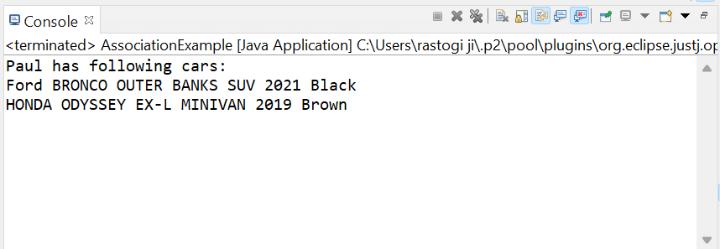

## Difference Between Aggregation and Composition

Let's understand the differences between Aggregation and Composition:

|  |  |  |
| --- | --- | --- |
| **S.No.** | **Aggregation** | **Composition** |
| 1. | Association between two objects that defines the "has-a" relationship is referred to as Aggregation. | A specific type of Aggregation that implies ownership is referred to as Composition. |
| 2. | In Aggregation, objects can remain in the scope of a system without each other. | In a composition relationship, objects cannot remain in the scope of a system without each other. |
| 3. | In Aggregation, linked objects are independent of each other. | In Composition, objects are tightly coupled or dependent on each other. |
| 4. | In Aggregation, if we delete the parent object, the child object will still exist in the system. For example, if we remove wheels from a car, the car can function adequately with another wheel. | In Composition, if we delete a parent object, the child object also gets deleted. For example, if we delete a folder, the files will also get deleted which contain in the folder. |
| 5. | We represent it by using the filled diamond. | We represent it by using the empty diamond. |
| 6. | In Aggregation, child objects don't have a lifetime. | In Composition, child objects have a lifetime. |
| 7. | In Aggregation, if we delete an assembly, it will never affect its parts. | In the case of owning a class, it affects the containing class object. |

**UML Diagram:**

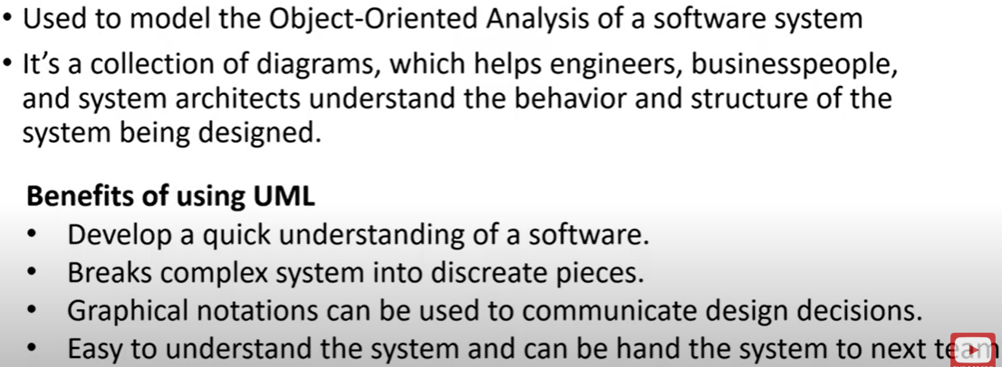

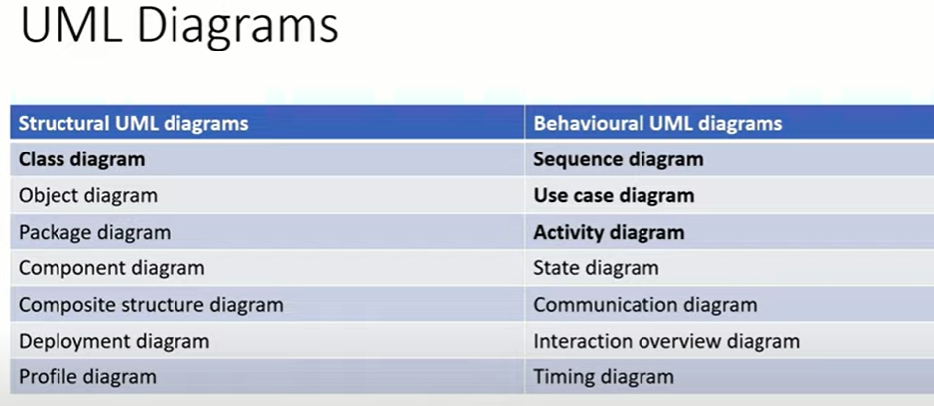

**Class Diagram:**

Because a lot of software is based on object-oriented programming, where developers define types of functions that can be used, class diagrams are the most commonly used type of UML diagram. [Class diagrams](https://www.lucidchart.com/pages/uml-class-diagram) show the static structure of a system, including classes, their attributes and behaviors, and the relationships between each class.

A class is represented by a rectangle that contains three compartments stacked vertically—the top compartment contains the class’s name and is mandatory, but the bottom two compartments give details about the class attributes and class operations or behaviors.

**Benefits of class diagrams**

Class diagrams offer a number of benefits for any organization. Use UML class diagrams to:

* Illustrate data models for information systems, no matter how simple or complex.
* Better understand the general overview of the schematics of an application.
* Visually express any specific needs of a system and disseminate that information throughout the business.
* Create detailed charts that highlight any specific code needed to be programmed and implemented to the described structure.
* Provide an implementation-independent description of types used in a system that are later passed between its components.

**Basic components of a class diagram**

The standard class diagram is composed of three sections:

* **Upper section:** Contains the name of the class. This section is always required, whether you are talking about the classifier or an object.
* **Middle section:** Contains the attributes of the class. Use this section to describe the qualities of the class. This is only required when describing a specific instance of a class.
* **Bottom section**: Includes class operations (methods). Displayed in list format, each operation takes up its own line. The operations describe how a class interacts with data.

**Member access modifiers**

All classes have different access levels depending on the access modifier (visibility). Here are the access levels with their corresponding symbols:

* Public (+)
* Private (-)
* Protected (#)
* Package (~)
* Derived (/)
* Static (underlined)

**Member scopes**

There are two scopes for members: classifiers and instances.

Classifiers are static members while instances are the specific instances of the class. If you are familiar with basic OO theory, this isn't anything groundbreaking.

**Additional class diagram components**

Depending on the context, classes in a class diagram can represent the main objects, interactions in the application, or classes to be programmed. To answer the question "What is a class diagram in UML?" you should first understand its basic makeup.

* **Classes**: A template for creating objects and implementing behavior in a system. In UML, a class represents an object or a set of objects that share a common structure and behavior. They're represented by a rectangle that includes rows of the class name, its attributes, and its operations. When you draw a class in a class diagram, you're only required to fill out the top row—the others are optional if you'd like to provide more detail.
  + **Name**: The first row in a class shape.
  + **Attributes**: The second row in a class shape. Each attribute of the class is displayed on a separate line.
  + Methods: The third row in a class shape. Also known as operations, methods are displayed in list format with each operation on its own line.
* **Signals**: Symbols that represent one-way, asynchronous communications between active objects.
* **Data types:** Classifiers that define data values. Data types can model both primitive types and enumerations.
* **Packages**: Shapes designed to organize related classifiers in a diagram. They are symbolized with a large tabbed rectangle shape.
* **Interfaces**: A collection of operation signatures and/or attribute definitions that define a cohesive set of behaviors. Interfaces are similar to classes, except that a class can have an instance of its type, and an interface must have at least one class to implement it.
* **Enumerations**: Representations of user-defined data types. An enumeration includes groups of identifiers that represent values of the enumeration.
* **Objects**: Instances of a class or classes. Objects can be added to a class diagram to represent either concrete or prototypical instances.
* **Artifacts**: Model elements that represent the concrete entities in a software system, such as documents, databases, executable files, software components, etc.

**Association :**

**Aggregation:** its is also called loose association

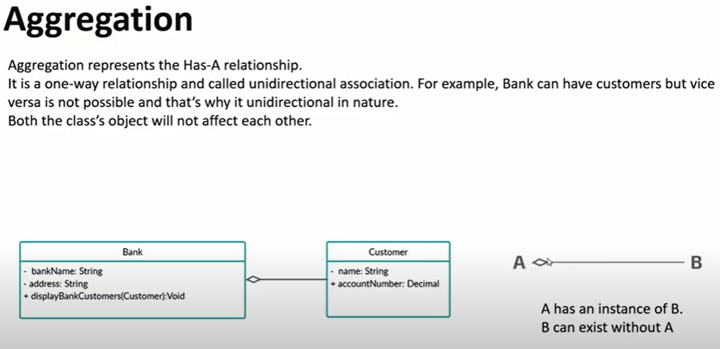

**Interactions**

The term "interactions" refers to the various relationships and links that can exist in class and object diagrams. Some of the most common interactions include:

* **Inheritance**: The process of a child or sub-class taking on the functionality of a parent or superclass, also known as generalization. It's symbolized with a straight connected line with a closed arrowhead pointing towards the superclass.

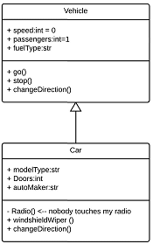

In this example, the object "Car" would inherit all of the attributes (speed, numbers of passengers, fuel) and methods (go(), stop(), changeDirection()) of the parent class ("Vehicle") in addition to the specific attributes (model type, number of doors, auto maker) and methods of its own class (Radio(), windshieldWiper(), ac/heat()). Inheritance is shown in a class diagram by using a solid line with a closed, hollow arrow.

* **Bidirectional association**: The default relationship between two classes. Both classes are aware of each other and their relationship with the other. This association is represented by a straight line between two classes.

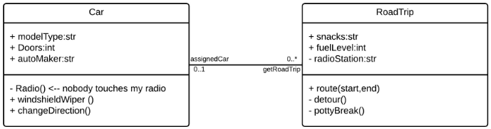

In the example above, the Car class and RoadTrip class are interrelated. At one end of the line, the Car takes on the association of "assignedCar" with the multiplicity value of 0..1, so when the instance of RoadTrip exists, it can either have one instance of Car associated with it or no Cars associated with it. In this case, a separate Caravan class with a multiplicity value of 0..* is needed to demonstrate that a RoadTrip could have multiple instances of Cars associated with it. Since one Car instance could have multiple "getRoadTrip" associations—in other words, one car could go on multiple road trips—the multiplicity value is set to 0..*

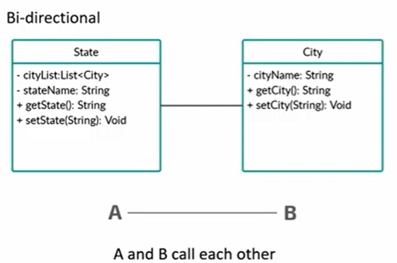

* **Unidirectional association**: A slightly less common relationship between two classes. One class is aware of the other and interacts with it. Unidirectional association is modeled with a straight connecting line that points an open arrowhead from the knowing class to the known class.

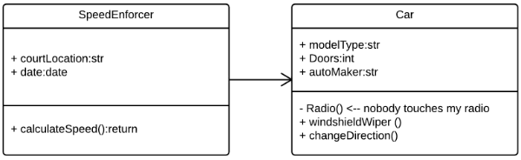

As an example, on your road trip through Arizona, you might run across a speed trap where a speed cam records your driving activity, but you won't know about it until you get a notification in the mail. It isn't drawn in the image, but in this case, the multiplicity value would be 0..* depending on how many times you drive by the speed cam.

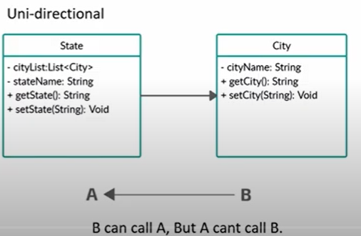

**Class diagram examples**

Creating a class diagram to map out process flows is easy. Consider the two examples below as you build your own class diagrams in UML.

**Class diagram for a hotel management system**

A class diagram can show the relationships between each object in a hotel management system, including guest information, staff responsibilities, and room occupancy. The example below provides a useful overview of the hotel management system. Get started on a class diagram by clicking the template below.

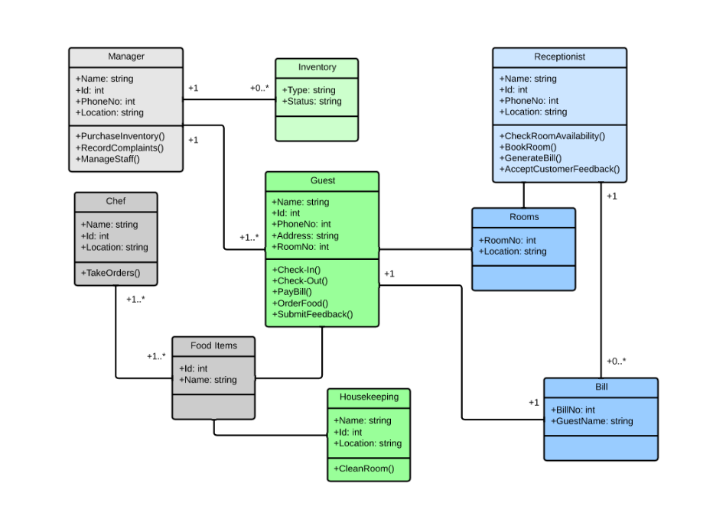

**Class diagram for an ATM system**

ATMs are deceptively simple: although customers only need to press a few buttons to receive cash, there are many layers of security that a safe and effective ATM must pass through to prevent fraud and provide value for banking customers. The various human and inanimate parts of an ATM system are illustrated by this easy-to-read diagram—every class has its title, and the attributes are listed beneath. You can edit, save, and share this chart by opening the document and signing up for a free Lucidchart account.

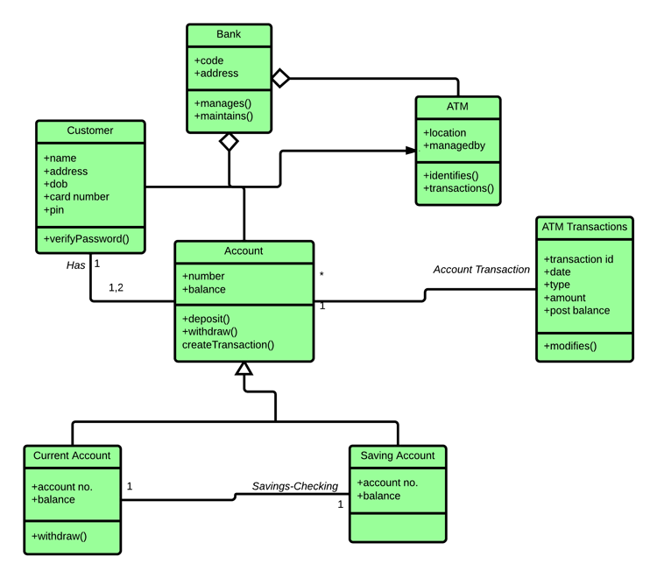

**Example:**

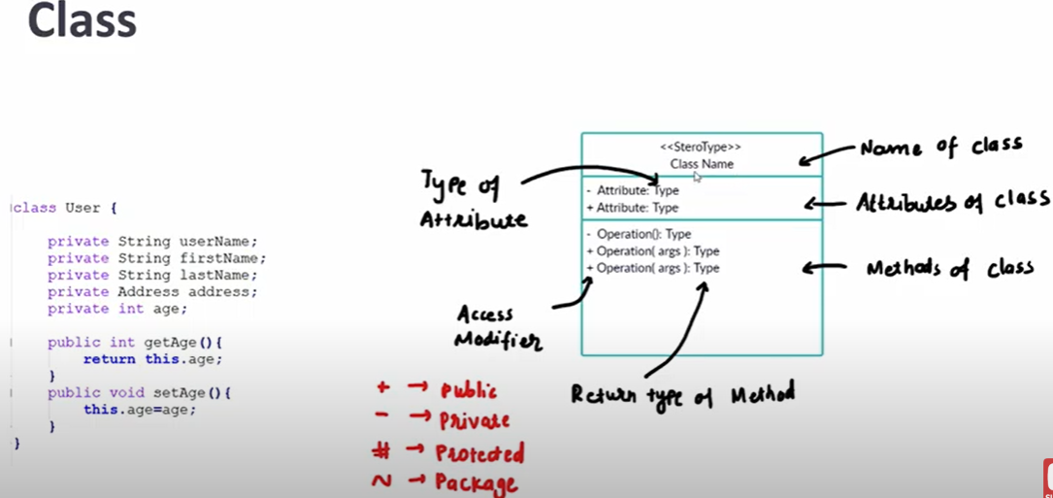

**Sequence Diagram:**

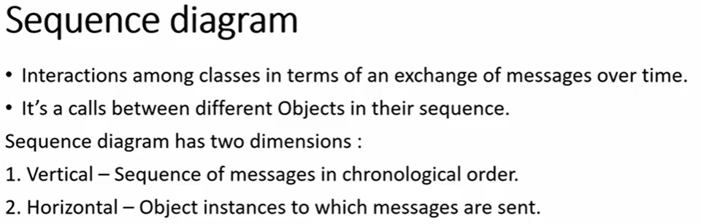

**Or**

Sequence diagram sometimes referred to as an event diagram or an event scenario, shows the order in which objects interact. This way, you can visually represent simple runtime scenarios.

## Benefits of sequence diagrams

Sequence diagrams can be useful references for businesses and other organizations. Try drawing a sequence diagram to:

* Represent the details of a UML use case.
* Model the logic of a sophisticated procedure, function, or operation.
* See how objects and components interact with each other to complete a process.
* Plan and understand the detailed functionality of an existing or future scenario.

## Use cases for sequence diagrams

The following scenarios are ideal for using a sequence diagram:

* **Usage scenario:** A usage scenario is a diagram of how your system could potentially be used. It's a great way to make sure that you have worked through the logic of every usage scenario for the system.
* **Method logic:** Just as you might use a UML sequence diagram to explore the logic of a use case, you can use it to explore the logic of any function, procedure, or complex process.
* **Service logic:** If you consider a service to be a high-level method used by different clients, a sequence diagram is an ideal way to map that out.
* **Sequence diagram Visio** - Any sequence diagram that you create with Visio can also be uploaded into Lucidchart. Lucidchart supports .vsd and .vdx file import and is a great Microsoft Visio alternative. Almost all of the images you see in the UML section of this site were generated using Lucidchart.

**Example:**

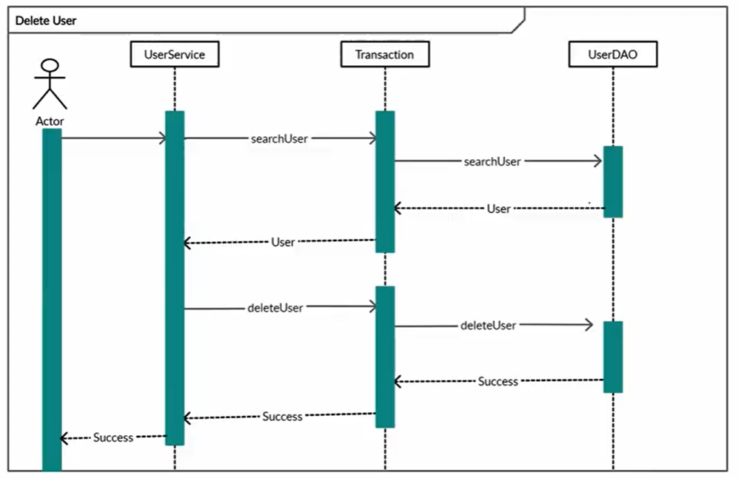

**Sequence diagram examples**

**Sequence diagram of a hospital management system**

Technology has completely transformed the field of medicine, as it has with most industries. A hospital information system, also known as a hospital information system, helps doctors, administrators, and hospital staff managing all of the activities and information collected at a hospital, including checkups, prescriptions, appointments, and information on the patients and their caretakers. The diagram below provides a simple view of how the primary processes operate with each other over time.

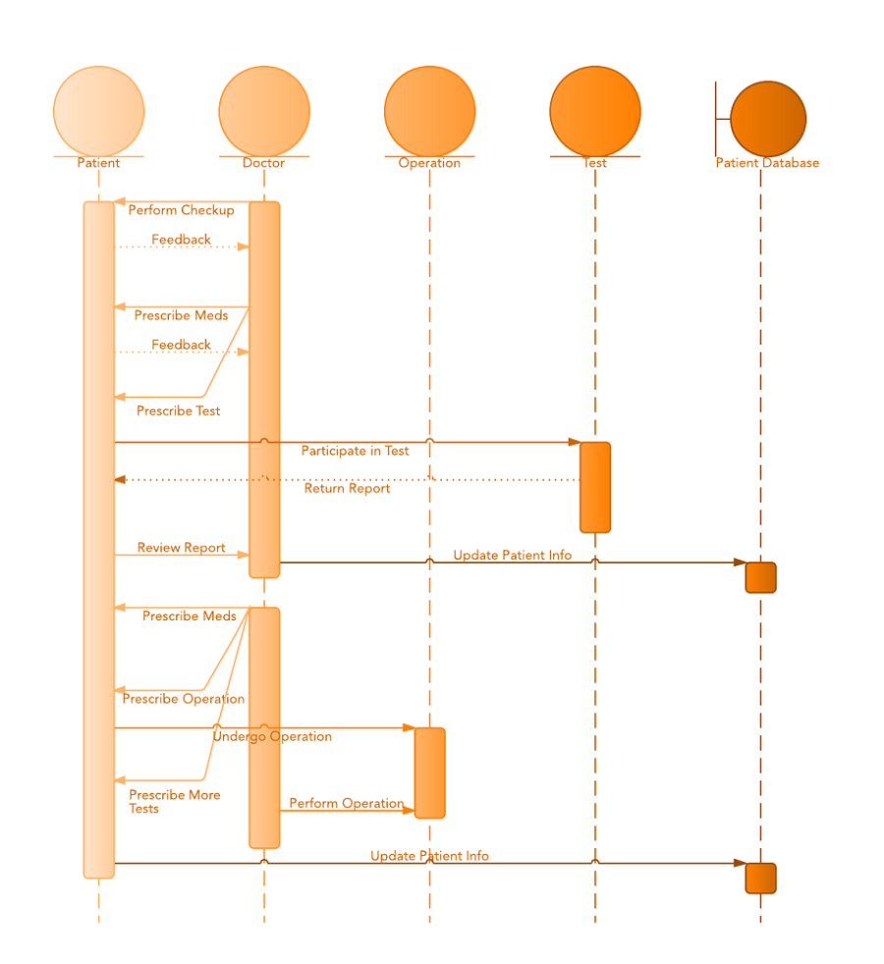

**Sequence diagram for ATM systems**

An ATM allows patrons to access their bank accounts through a completely automated process. You can examine the steps of this process in a manageable way by drawing or viewing a sequence diagram. The example below outlines the sequential order of the interactions in the ATM system.

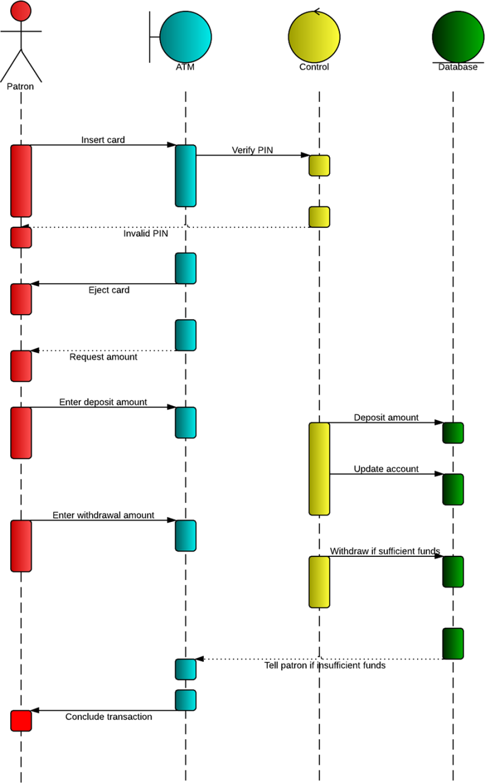

**How to make**

**Use Case Diagram:**

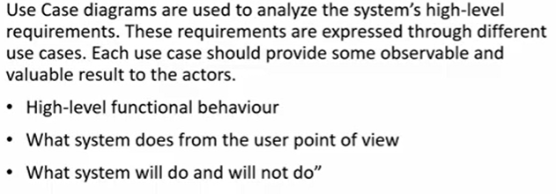

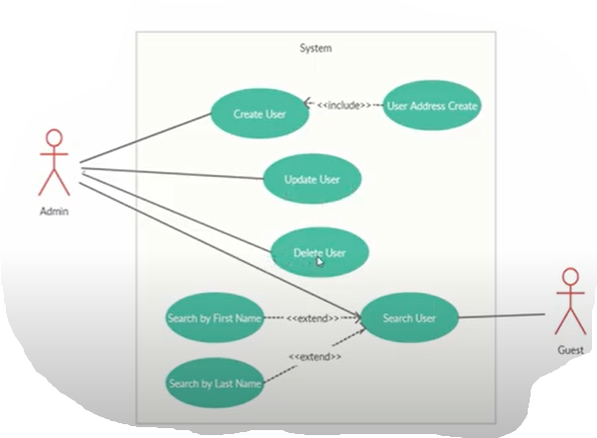

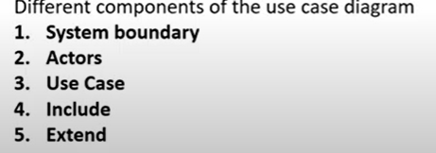

**OR**

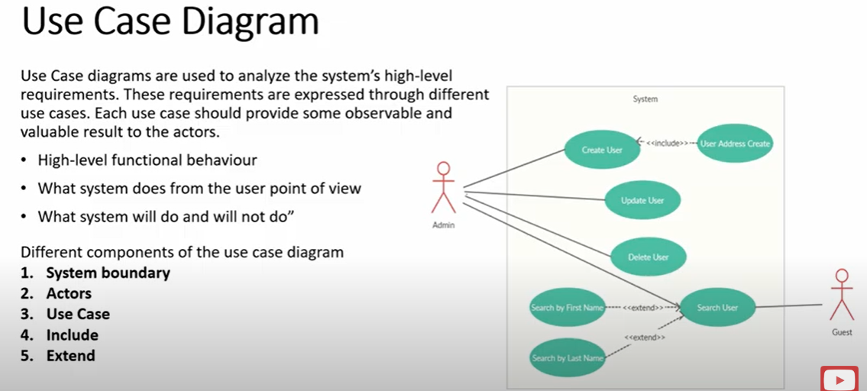

## What is a use case diagram?

In the Unified Modeling Language (UML), a use case diagram can summarize the details of your system's users (also known as actors) and their interactions with the system. To build one, you'll use a set of specialized symbols and connectors. An effective use case diagram can help your team discuss and represent:

* Scenarios in which your system or application interacts with people, organizations, or external systems
* Goals that your system or application helps those entities (known as actors) achieve
* The scope of your system

**When to apply use case diagrams**

A use case diagram doesn't go into a lot of detail—for example, don't expect it to model the order in which steps are performed. Instead, a proper use case diagram depicts a high-level overview of the relationship between use cases, actors, and systems. Experts recommend that use case diagrams be used to supplement a more descriptive textual use case.

UML is the modeling toolkit that you can use to build your diagrams. Use cases are represented with a labeled oval shape. Stick figures represent actors in the process, and the actor's participation in the system is modeled with a line between the actor and use case. To depict the system boundary, draw a box around the use case itself.

UML use case diagrams are ideal for:

* Representing the goals of system-user interactions
* Defining and organizing functional requirements in a system
* Specifying the context and requirements of a system
* Modeling the basic flow of events in a use case

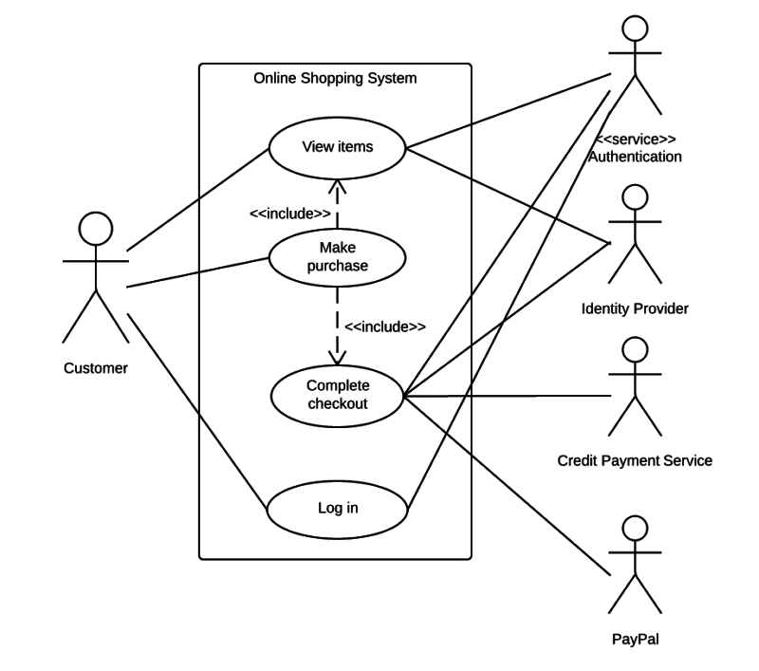

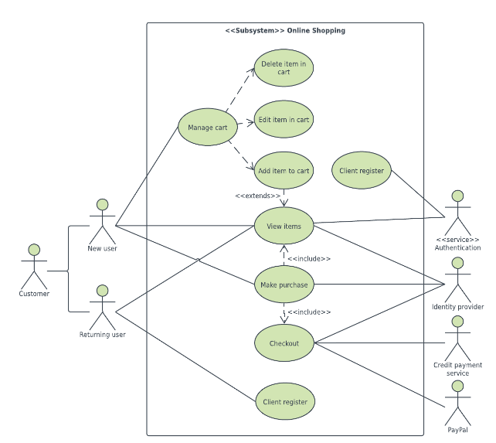

**Use case diagram components**

To answer the question, "What is a use case diagram?" you need to first understand its building blocks. Common components include:

* **Actors**: The users that interact with a system. An actor can be a person, an organization, or an outside system that interacts with your application or system. They must be external objects that produce or consume data.
* **System**: A specific sequence of actions and interactions between actors and the system. A system may also be referred to as a scenario.
* **Goals**: The end result of most use cases. A successful diagram should describe the activities and variants used to reach the goal.

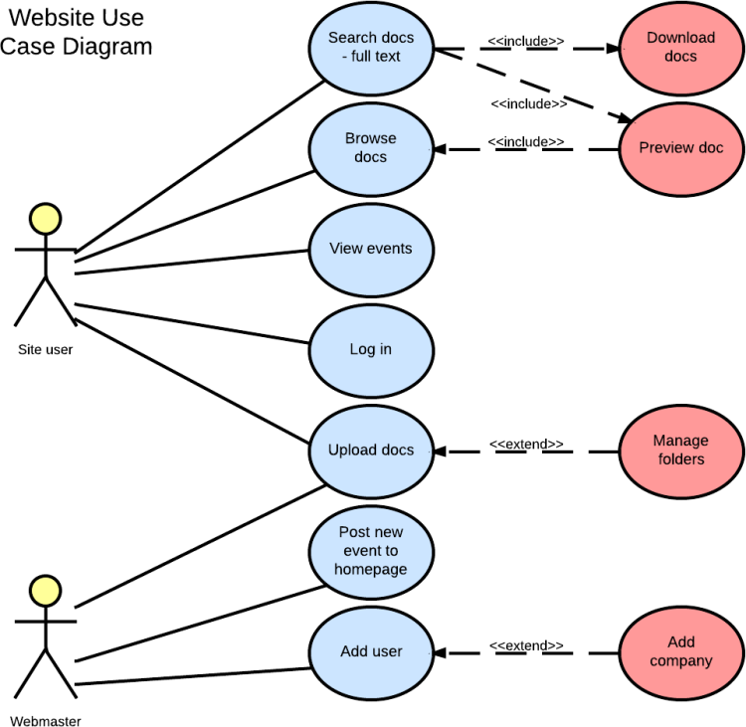

**Use case diagram symbols and notation**

The notation for a use case diagram is pretty straightforward and doesn't involve as many types of symbols as other UML diagrams. You can use this guide to learn [how to draw a use case diagram](https://www.lucidchart.com/pages/how-to-draw-a-use-case-diagram-in-UML) if you need a refresher. Here are all the shapes you will be able to find in Lucidchart:

* **Use cases:** Horizontally shaped ovals that represent the different uses that a user might have.
* **Actors**: Stick figures that represent the people actually employing the use cases.
* **Associations**: A line between actors and use cases. In complex diagrams, it is important to know which actors are associated with which use cases.
* **System boundary boxes**: A box that sets a system scope to use cases. All use cases outside the box would be considered outside the scope of that system. For example, Psycho Killer is outside the scope of occupations in the chainsaw example found below.
* **Packages**: A UML shape that allows you to put different elements into groups. Just as with component diagrams, these groupings are represented as file folders.

**Use case diagram examples**

**Book publishing use case diagram example**

This use case diagram is a visual representation of the process required to write and publish a book. Whether you’re an author, an agent, or a bookseller, inserting this diagram into your use case scenario can help your team publish the next big hit. [Try this demo template](https://lucid.app/lucidchart/editNewOrRegister/a6331f6f-0e33-48d5-bc1d-68f25d05b437) to get started on your own.

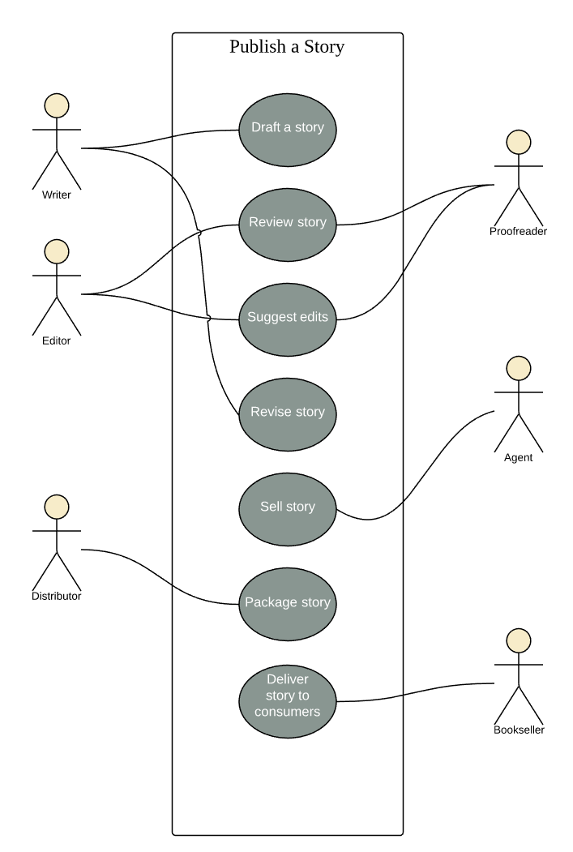

**Railway reservation use case diagram example**

You can adapt this template for any process where a customer purchases a service. With attractive color schemes, text that’s easy to read and edit, and a wide-ranging UML shape library, you’re ready to go! Click to [try out this template](https://www.lucidchart.com/documents/editNewOrRegister/6641f344-e2ce-4138-a2c8-7fad5ad13fb2/) on your own.

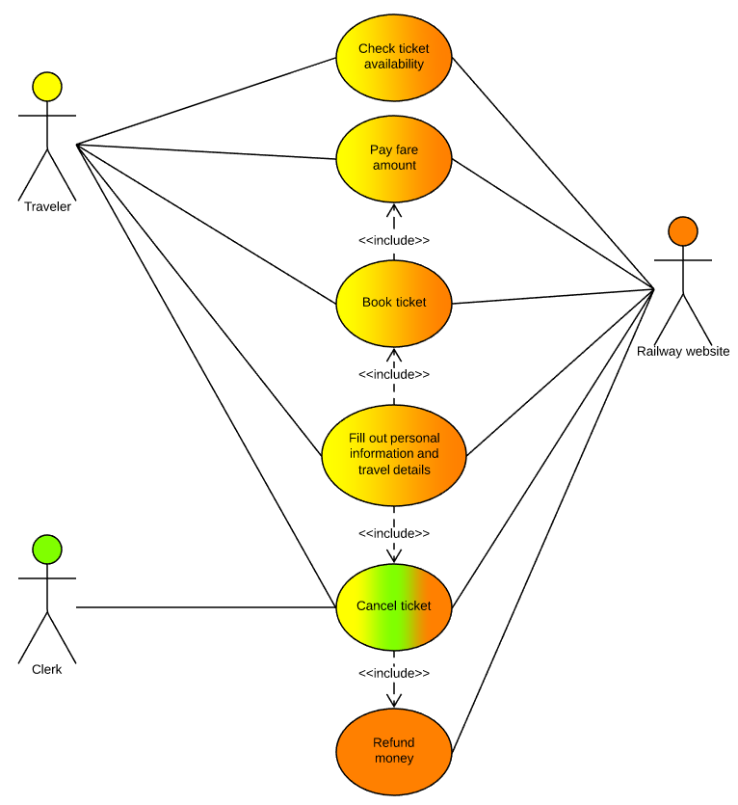

**Chainsaw use case diagram example**

Consider this example: A man with a chainsaw interacts with the environment around him. Depending on the situation and the context of the situation, he might fall into one of many different use cases. Does he seem to be on his way to work? Is there anything ominous about the way he is wielding his chainsaw? For example, if he is using the chainsaw in a non-occupational setting, we might have reason to think that he falls within the scope of "scary."

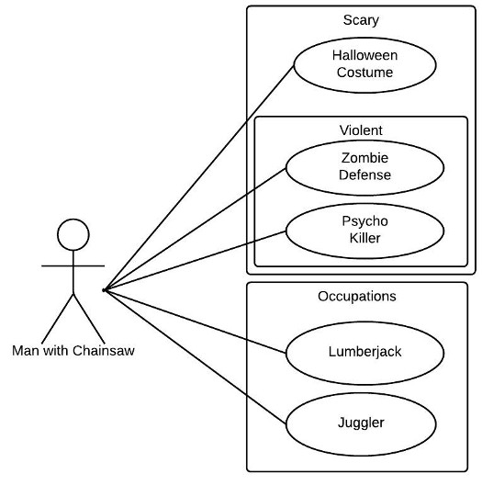

**Activity Diagram:**

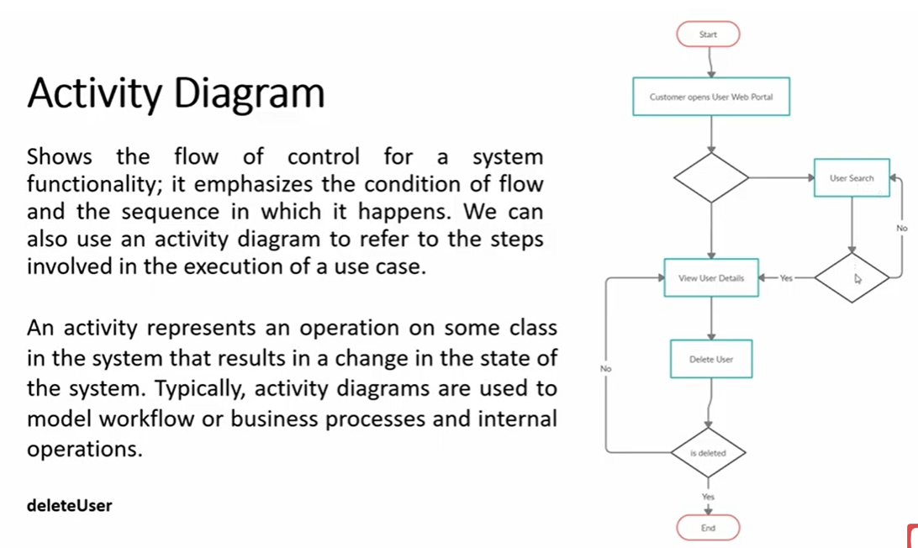

## Benefits of activity diagrams

Activity diagrams present a number of benefits to users. Consider creating an activity diagram to:

* Demonstrate the logic of an algorithm.
* Describe the steps performed in a UML use case.
* Illustrate a business process or workflow between users and the system.
* Simplify and improve any process by clarifying complicated use cases.
* Model software architecture elements, such as method, function, and operation.

## Basic components of an activity diagram

Before you begin making an activity diagram, you should first understand its makeup. Some of the most common components of an activity diagram include:

* **Action:**A step in the activity wherein the users or software perform a given task. In Lucidchart, actions are symbolized with round-edged rectangles.
* **Decision node:** A conditional branch in the flow that is represented by a diamond. It includes a single input and two or more outputs.
* **Control flows:** Another name for the connectors that show the flow between steps in the diagram.
* **Start node:** Symbolizes the beginning of the activity. The start node is represented by a black circle.
* **End node:** Represents the final step in the activity. The end node is represented by an outlined black circle
* **Activity diagram symbols**
* These activity diagram shapes and symbols are some of the most common types you'll find in UML diagrams.

| Symbol | Name | Description |
| --- | --- | --- |
| start Symbol | Start symbol | Represents the beginning of a process or workflow in an activity diagram. It can be used by itself or with a note symbol that explains the starting point. |
| activity Symbol | Activity symbol | Indicates the activities that make up a modeled process. These symbols, which include short descriptions within the shape, are the main building blocks of an activity diagram. |
| connector Symbol | Connector symbol | Shows the directional flow, or control flow, of the activity. An incoming arrow starts a step of an activity; once the step is completed, the flow continues with the outgoing arrow. |
| joint Symbol | Joint symbol/ Synchronization bar | Combines two concurrent activities and re-introduces them to a flow where only one activity occurs at a time. Represented with a thick vertical or horizontal line. |
| fork Symbol | Fork symbol | Splits a single activity flow into two concurrent activities. Symbolized with multiple arrowed lines from a join. |
| decision Symbol | Decision symbol | Represents a decision and always has at least two paths branching out with condition text to allow users to view options. This symbol represents the branching or merging of various flows with the symbol acting as a frame or container. |
| note Symbol | Note symbol | Allows the diagram creators or collaborators to communicate additional messages that don't fit within the diagram itself. Leave notes for added clarity and specification. |
| send signal Symbol | Send signal symbol | Indicates that a signal is being sent to a receiving activity. |
| receive signal Symbol | Receive signal symbol | Demonstrates the acceptance of an event. After the event is received, the flow that comes from this action is completed. |
| shallow history pseudostate symbol | Shallow history pseudostate symbol | Represents a transition that invokes the last active state. |
| option loop symbol | Option loop symbol | Allows the creator to model a repetitive sequence within the option loop symbol. |
| flow final symbol | Flow final symbol | Represents the end of a specific process flow. This symbol shouldn’t represent the end of all flows in an activity; in that instance, you would use the end symbol. The flow final symbol should be placed at the end of a process in a single activity flow. |
| condition text | Condition text | Placed next to a decision marker to let you know under what condition an activity flow should split off in that direction. |
| end symbol | End symbol | Marks the end state of an activity and represents the completion of all flows of a process. |

* **Activity diagram examples**
* Activity diagrams map out process flows in a way that's easy to understand. Consider the two examples below when it comes to creating UML activity diagrams.
* **Activity diagram for a login page**
* Many of the activities people want to accomplish online—checking email, managing finances, ordering clothes, etc.—require them to log into a website. This activity diagram shows the process of logging into a website, from entering a username and password to successfully logging in to the system. It uses different container shapes for activities, decisions, and notes. Lucidchart is the ideal tool for creating any kind of UML flowchart, whether it’s an activity diagram, a use case diagram, or a component diagram. Lucidchart offers in-editor collaboration tools and instant web publishing so you can demonstrate the functionality of your system to others.
* 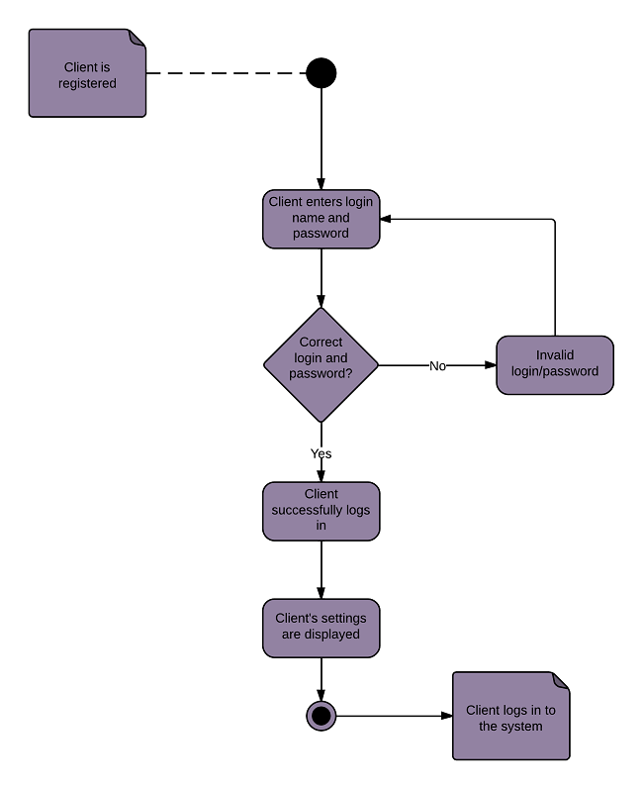

**Activity diagram for a banking system**

This diagram shows the process of either withdrawing money from or depositing money into a bank account. An advantage of representing the workflow visually in UML is the ability to show withdrawals and deposits on one chart. When you use Lucidchart to build an activity diagram, you can customize your templates with professional-grade typefaces and colors. Never worry about losing your documents with secure, cloud-based storage.

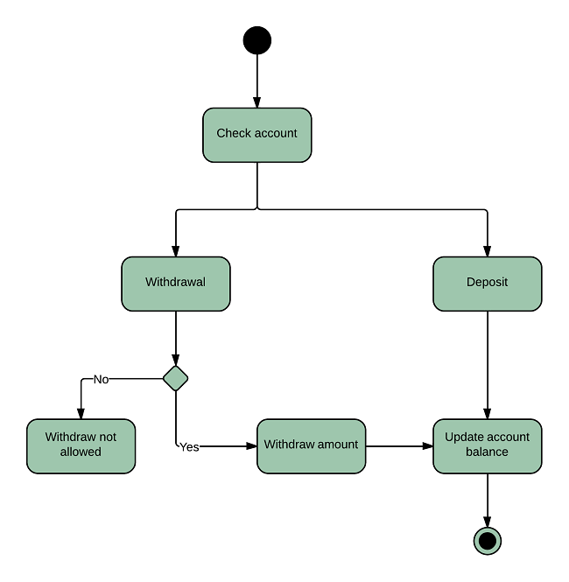

**SOLID Principles:**

**Benefits of SOLID:**

* Loose Coupling
* Code maintainability
* Dependency Management

## Single Responsibility Principle

The single responsibility principle states that **every Java class must perform a single functionality**. Implementation of multiple functionalities in a single class mashup the code and if any modification is required may affect the whole class. It precise the code and the code can be easily maintained. Let's understand the single responsibility principle through an example.

Suppose, **Student** is a class having three methods namely **printDetails(), calculatePercentage(),** and **addStudent().** Hence, the Student class has three responsibilities to print the details of students, calculate percentages, and database. By using the single responsibility principle, we can separate these functionalities into three separate classes to fulfill the goal of the principle.

**Student.java**

1. **public** **class** Student
2. {
3. **public** **void** printDetails();
4. {
5. //functionality of the method
6. }
7. pubic **void** calculatePercentage();
8. {
9. //functionality of the method
10. }
11. **public** **void** addStudent();
12. {
13. //functionality of the method
14. }
15. }

The above code snippet violates the single responsibility principle. To achieve the goal of the principle, we should implement a separate class that performs a single functionality only.

**Student.java**

1. **public** **class** Student
2. {
3. **public** **void** addStudent();
4. {
5. //functionality of the method
6. }
7. }

**PrintStudentDetails.java**

1. **public** **class** PrintStudentDetails
2. {
3. **public** **void** printDetails();
4. {
5. //functionality of the method
6. }
7. }

**Percentage.java**

1. **public** **class** Percentage
2. {
3. **public** **void** calculatePercentage();
4. {
5. //functionality of the method
6. }
7. }

Hence, we have achieved the goal of the single responsibility principle by separating the functionality into three separate classes.

Open-Closed Principle

(Extends or implements)

The open-closed principle states that according to new requirements **the module should be open for extension but closed for modification.** The extension allows us to implement new functionality to the module. Let's understand the principle through an example.

Suppose, **VehicleInfo** is a class and it has the method **vehicleNumber()** that returns the vehicle number.

**VehicleInfo.java**

1. **public** **class** VehicleInfo
2. {
3. **public** **double** vehicleNumber(Vehicle vcl)
4. {
5. **if** (vcl **instanceof** Car)
6. {
7. **return** vcl.getNumber();
8. **if** (vcl **instanceof** Bike)
9. {
10. **return** vcl.getNumber();
11. }
12. }

If we want to add another subclass named Truck, simply, we add one more if statement that violates the open-closed principle. The only way to add the subclass and achieve the goal of principle by overriding the **vehicleNumber()** method, as we have shown below.

**VehicleInfo.java**

1. **public** **class** VehicleInfo
2. {
3. **public** **double** vehicleNumber()
4. {
5. //functionality
6. }
7. }
8. **public** **class** Car **extends** VehicleInfo
9. {
10. **public** **double** vehicleNumber()
11. {
12. **return** **this**.getValue();
13. }
14. **public** **class** Car **extends** Truck
15. {
16. **public** **double** vehicleNumber()
17. {
18. **return** **this**.getValue();
19. }

Similarly, we can add more vehicles by making another subclass extending from the vehicle class. the approach would not affect the existing application.

**Example:**

**Voilates OCP:**

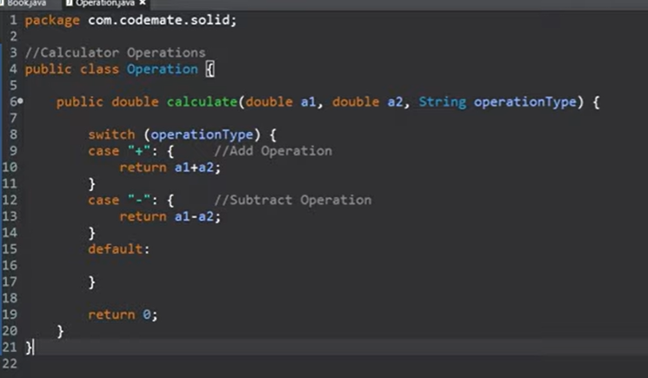

**Follows OCP:**

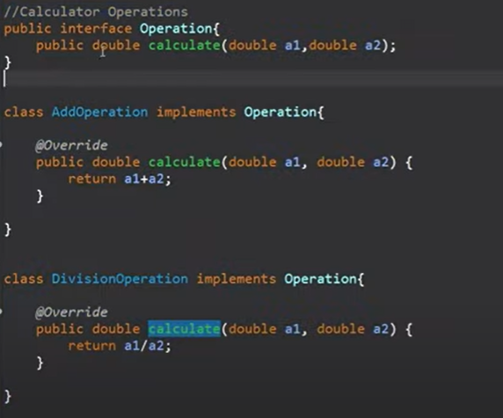

**Liskov Substitution principle:**

 It applies to inheritance in such a way that the **derived classes must be completely substitutable for their base classes**. In other words, if class A is a subtype of class B, then we should be able to replace B with A without interrupting the behavior of the program.

It extends the open-close principle and also focuses on the behavior of a superclass and its subtypes. We should design the classes to preserve the property unless we have a strong reason to do otherwise.

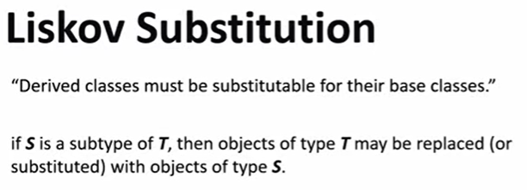

**Example 1 :**

**Violates of Liskov Substitution principle:**

public interface Vechile{

  void startEngine();

}

class Car extends Vechile{

  void startEngine(){

      System.out.println("Start Engine");

  }

}

class Bycycle extends Vechile{

  // but bycycle does not have the engine to start.

  void startEngine(){

      throw NotFoundException ;

  }

}

**The above example we can’t have startEngine method in Bycycle class so we cant replace the base or parent class with child class.below example Follow the Liskov substitution principle.**

public interface Vechile{

  void display();

}

class withEngine implements Vechile {

  void startEngine() {

      ..........

  }

  void display(){

      .............

  }

}

class withOutEngine implements vechile {

    void startMoving() {

      ..........

  }

   void display(){

      .............

  }

}

class Car extends withEngine{

  @Override

  void startEngine(){

      System.out.println("Start Engine");

  }

  @Override

   void display(){

      .............

  }

}

class Bycycle extends withOutEngine{

  @Override

  void stratMoving(){

     .........

  }

  @Override

  void display(){

      .............

  }

}

**Example 2:**

Delivery -> offline delivery -> online E copy delivery

Offline delivery has address method extends the DeliveryAddressClass ,

Online delivery has submitted copy method, extends the E-CpoyClass .

**Example 3:**

Let's do a simple example in Java:

## Bad example

public class Bird{

  public void fly(){}

}

public class Duck extends Bird{}

The duck can fly because it is a bird, but what about this:

public class Ostrich extends Bird{}

Ostrich is a bird, but it can't fly, Ostrich class is a subtype of class Bird, but it shouldn't be able to use the fly method, that means we are breaking the LSP principle.

## Good example

public class Bird{}

public class FlyingBirds extends Bird{

    public void fly(){}

}

public class Duck extends FlyingBirds{}

public class Ostrich extends Bird{}

**Example 4:**

Let’s illustrate in Java:

class TrasportationDevice

{

   String name;

   String getName() { ... }

   void setName(String n) { ... }

   double speed;

   double getSpeed() { ... }

   void setSpeed(double d) { ... }

   Engine engine;

   Engine getEngine() { ... }

   void setEngine(Engine e) { ... }

   void startEngine() { ... }

}

class Car extends TransportationDevice

{

   @Override

   void startEngine() { ... }

}

There is no problem here, right? A car is definitely a transportation device, and here we can see that it overrides the startEngine() method of its superclass.

Let’s add another transportation device:

class Bicycle extends TransportationDevice

{

   @Override

   void startEngine() /*problem!*/

}

Everything isn’t going as planned now! Yes, a bicycle is a transportation device, however, it does not have an engine and hence, the method startEngine() cannot be implemented.

These are the kinds of problems that violation of Liskov Substitution Principle leads to, and they can most usually be recognized by a method that does nothing, or even can’t be implemented.

The solution to these problems is a correct inheritance hierarchy, and in our case we would solve the problem by differentiating classes of transportation devices with and without engines. Even though a bicycle is a transportation device, it doesn’t have an engine. In this example our definition of transportation device is wrong. It should not have an engine.

We can refactor our TransportationDevice class as follows:

class TrasportationDevice

{

   String name;

   String getName() { ... }

   void setName(String n) { ... }

   double speed;

   double getSpeed() { ... }

   void setSpeed(double d) { ... }

}

Now we can extend TransportationDevice for non-motorized devices.

class DevicesWithoutEngines extends TransportationDevice

{

   void startMoving() { ... }

}

And extend TransportationDevice for motorized devices. Here is is more appropriate to add the Engine object.

class DevicesWithEngines extends TransportationDevice

{

   Engine engine;

   Engine getEngine() { ... }

   void setEngine(Engine e) { ... }

   void startEngine() { ... }

}

Thus our Car class becomes more specialized, while adhering to the Liskov Substitution Principle.

class Car extends DevicesWithEngines

{

   @Override

   void startEngine() { ... }

}

And our Bicycle class is also in compliance with the Liskov Substitution Principle.

class Bicycle extends DevicesWithoutEngines

{

   @Override

   void startMoving() { ... }

}

Interface Segregation Principle

The principle states that the larger interfaces split into smaller ones. Because the implementation classes use only the methods that are required. We should not force the client to use the methods that they do not want to use .

The goal of the interface segregation principle is similar to the single responsibility principle. Let's understand the principle through an example.

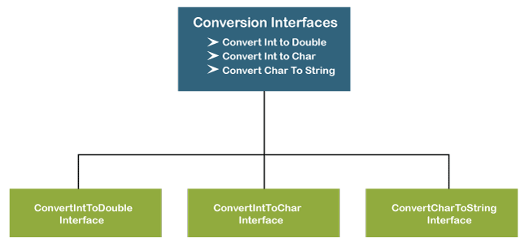

Suppose, we have created an interface named **Conversion** having three methods **intToDouble(), intToChar(),** and **charToString()**.

1. **public** **interface** Conversion
2. {
3. **public** **void** intToDouble();
4. **public** **void** intToChar();
5. **public** **void** charToString();
6. }

The above interface has three methods. If we want to use only a method intToChar(), we have no choice to implement the single method. To overcome the problem, the principle allows us to split the interface into three separate ones.

1. **public** **interface** ConvertIntToDouble
2. {
3. **public** **void** intToDouble();
4. }
5. **public** **interface** ConvertIntToChar
6. {
7. **public** **void** intToChar();
8. }
9. **public** **interface** ConvertCharToString
10. {
11. **public** **void** charToString();
12. }

Now we can use only the method that is required. Suppose, we want to convert the integer to double and character to string then, we will use only the methods **intToDouble()** and **charToString().**

1. **public** **class** DataTypeConversion **implements** ConvertIntToDouble, ConvertCharToString
2. {
3. **public** **void** intToDouble()
4. {
5. //conversion logic
6. }
7. **public** **void** charToString()
8. {
9. //conversion logic
10. }
11. }

**Example 1:**

**Bad (Voilates) Example:**

Consider the requirements of an application that builds different types of transportation vehicles. Each vehicle will have a price and color. Vehicles such as **car**can start and stop moving while some vehicles such as **airplanes** can both move and fly. Example interface

## Vehicle.java

public interface Vehicle {  
 void setPrice(double price);  
 void setColor(String color);  
 void start();  
 void stop();  
 void fly();  
}

A class that represents an aeroplane can implement the Vehicle interface and provide implementations of all the interface methods. But, imagine a class that represents a car. This is how the Car class will look.

## Car.java

public class Car implements Vehicle {  
 double price;  
 String color;  
 @Override  
 public void setPrice(double price) {  
 this.price = price;  
 }  
 @Override  
 public void setColor(String color) {  
 this.color=color;  
 }  
 @Override  
 public void start(){}  
 @Override  
 public void stop(){}  
 @Override  
 public void fly(){}   
}

As you can see in the code, Car needs to provide an implementation **fly**() method, even though it does not require them. This is a violation of the Interface Segregation Principle. These might affect code readability

**Follows ISP:**

Following the Interface Segregation Principle, we can address the problem of the vehicle interface, solution is- Segregate the Vehicle interface into multiple role interfaces each for specific behavior. In this case, Vehicle interface can be broken down into three interfaces: Toy, Movable, and Flyable.

## Vehicle.java

public interface Vehicle {  
 void setPrice(double price);  
 void setColor(String color);  
}

## Movable.java

public interface Movable {  
 void start();  
 void stop();  
}

## Flyable.java

public interface Flyable {  
 void fly();  
}

Now Vehicle interface with the **setPrice**() and **setColor**() methods as all vehicles will have a price and color, all Vehicle implementation classes can implement this interface. Then, Movable and Flyable interfaces to represent moving and flying behaviors in vehicles.

# Implementation

## Car.java

public class Car implements Vehicle, Movable {  
 double price;  
 String color;  
​  
 @Override  
 public void setPrice(double price) {  
​  
 this.price = price;  
 }  
 @Override  
 public void setColor(String color) {  
​  
 this.color=color;  
 }  
 @Override  
 public void start(){  
 // Implementation  
 }  
 @Override  
 public void stop(){  
 // Implementation  
 }  
}

## Aeroplane.java

public class Aeroplane implements Vehicle, Movable, Flyable {  
 double price;  
 String color;  
​  
 @Override  
 public void setPrice(double price) {  
​  
 this.price = price;  
 }  
​  
 @Override  
 public void setColor(String color) {  
 this.color=color;  
 }  
 @Override  
 public void start(){  
 // Implementation  
 }  
 @Override  
 public void stop(){  
 // Implementation  
 }  
 @Override  
 public void fly(){  
 // Implementation  
 }  
}

Now implementation classes implement those interfaces they are interested in and this helps to remove unnecessary code and is more readable

Next, let’s write a class to create objects of the implementation classes.

## VehicleBuilder.java

public class VehicleBuilder {  
 public static Car buildCar(){  
 ToyHouse toyHouse=new ToyHouse();  
 Car car = new Car();  
 car.setPrice(15.00);  
 car.setColor("green");  
 car.start();  
 return car;  
 }  
 public static Aeroplane buildAeroPlane(){  
 Aeroplane aeroplane = new Aeroplane();  
 aeroplane.setPrice(25.00);  
 aeroplane.setColor("red");  
 aeroplane.start();  
 aeroplane.fly();  
 return aeroplane;  
 }  
}

**Example 2 :**

With that sorted, let's break up the interfaces and apply the Interface Segregation Principle. Thus, we now have a common interface:

public interface Payment {

  Object status();

  List<Object> getPayments();

}

And two more interfaces for the two types of payments:

public interface Bank extends Payment {

  void initiatePayments();

}

public interface Loan extends Payment {

  void intiateLoanSettlement();

  void initiateRePayment();

}

And the respective implementations, starting with *BankPayment*:

public class BankPayment implements Bank {

  @Override

  public void initiatePayments() {

      // ...

  }

  @Override

  public Object status() {

      // ...

  }

  @Override

  public List<Object> getPayments() {

      // ...

  }

}

And finally, our revised *LoanPayment* implementation:

public class LoanPayment implements Loan {

  @Override

  public void intiateLoanSettlement() {

      // ...

  }

  @Override

  public void initiateRePayment() {

      // ...

  }

  @Override

  public Object status() {

      // ...

  }

  @Override

  public List<Object> getPayments() {

      // ...

  }

}

Now, let's review the new class diagram:

[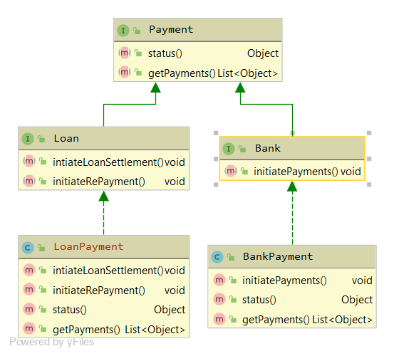](https://www.baeldung.com/wp-content/uploads/2020/07/interface_segregation_fixed.png)

**As we can see, the interfaces don't violate the principle.** The implementations don't have to provide empty methods. This keeps the code clean and reduces the chance of bugs.

**Example 3:**

Assume that you have one fat interface with many methods to be implemented.

Any class, that implements that fat interface has to provide implementation for all these methods. Some of the methods may not be applicable to that concrete class. But still it has to provide implementation in absence of interface segregation principle.

Let's have a look at example code in absence of Interface segregation

**Violates ISP:**

interface Shape{

  public int getLength();

  public int getWidth();

  public int getRadius();

  public double getArea();

}

class Rectangle implements Shape{

  int length;

  int width;

  public Rectangle(int length, int width){

      this.length = length;

      this.width = width;

  }

  public int getLength(){

      return length;

  }

  public int getWidth(){

      return width;

  }

  public int getRadius(){

      // Not applicable

      return 0;

  }

  public double getArea(){

      return width * length;

  }

}

class Square implements Shape{

  int length;

  public Square(int length){

      this.length = length;

  }

  public int getLength(){

      return length;

  }

  public int getWidth(){

      // Not applicable

      return 0;

  }

  public int getRadius(){

      // Not applicable

      return 0;

  }

  public double getArea(){

      return length * length;

  }

}

class Circle implements Shape{

  int radius;

  public Circle(int radius){

      this.radius = radius;

  }

  public int getLength(){

      // Not applicable

      return 0;

  }

  public int getWidth(){

      // Not applicable

      return 0;

  }

  public int getRadius(){

      return radius;

  }

  public double getArea(){

      return 3.14* radius * radius;

  }

}

public class InterfaceNoSeggration{

  public static void main(String args[]){

      Rectangle r = new Rectangle(10,20);

      Square s = new Square(15);

      Circle c = new Circle(2);

      System.out.println("Rectangle area:"+r.getArea());

      System.out.println("Square area:"+s.getArea());

      System.out.println("Circle area:"+c.getArea());

  }

}

**output:**

java InterfaceNoSeggration

Rectangle area:200.0

Square area:225.0

Circle area:12.56

**Notes**:

1. Shape is a general purpose fat interface, which contains methods required for all Shape implementations like Rectangle, Circle and Square. But only some methods are needed in respective Shape childs

Rectangle : getLength(), getWidth(), getArea()

Square : getLength() and getArea()

Circle : getRadius() and getArea()

1. In absence of segregation, all Shapes have implemented entire fat interface : Shape.

We can achieve same output with interface segregation principle if we change the code as follows.

**Follows ISP:**

interface Length{

  public int getLength();

}

interface Width{

  public int getWidth();

}

interface Radius{

  public int getRadius();

}

interface Area {

  public double getArea();

}

class Rectangle implements Length,Width,Area{

  int length;

  int width;

  public Rectangle(int length, int width){

      this.length = length;

      this.width = width;

  }

  public int getLength(){

      return length;

  }

  public int getWidth(){

      return width;

  }

  public int getRadius(){

      // Not applicable

      return 0;

  }

  public double getArea(){

      return width * length;

  }

}

class Square implements Length,Area{

  int length;

  public Square(int length){

      this.length = length;

  }

  public int getLength(){

      return length;

  }

  public int getWidth(){

      // Not applicable

      return 0;

  }

  public int getRadius(){

      // Not applicable

      return 0;

  }

  public double getArea(){

      return length * length;

  }

}

class Circle implements Radius,Area{

  int radius;

  public Circle(int radius){

      this.radius = radius;

  }

  public int getLength(){

      // Not applicable

      return 0;

  }

  public int getWidth(){

      // Not applicable

      return 0;

  }

  public int getRadius(){

      return radius;

  }

  public double getArea(){

      return 3.14* radius * radius;

  }

}

public class InterfaceSeggration{

  public static void main(String args[]){

      Rectangle r = new Rectangle(10,20);

      Square s = new Square(15);

      Circle c = new Circle(2);

      System.out.println("Rectangle area:"+r.getArea());

      System.out.println("Square area:"+s.getArea());

      System.out.println("Circle area:"+c.getArea());

  }

}

**Dependency Inversion principle:**

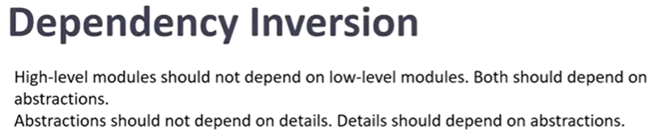

**Violates DIP:**

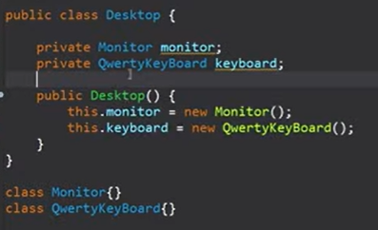

**Follows DIP:**

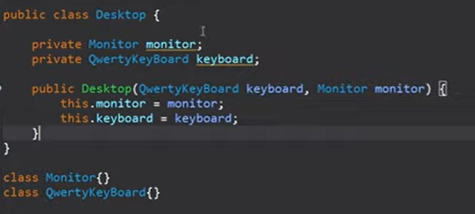

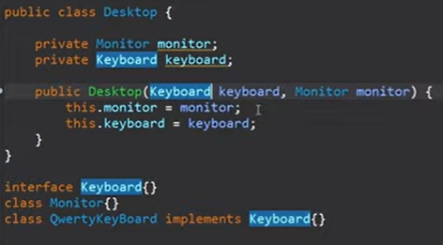

**Types of Design**

**High-Level Design (HLD)**

**High-Level Design (HLD)** is a general system design. It includes the description of the following parts:

* System architecture
* Database design
* Brief mention of all the platforms, systems, services, and processes the product would depend on
* Brief description of relationships between the modules and system features

All the data flows, flowcharts, data structures, etc. are in these docs so that developers can understand how the system is expected to work with regards to the features and the database design.

Basically the HLD is based on the requirements of the customer.

**Low-Level Design (HLD)**

**Low-Level Design (LLD)** is a component-level design process that follows a step-by-step refinement process. It provides the details and definitions for the actual logic for every system component. It is based on HLD but digs deeper, going into the separate modules and features for every program in order to document their specifications.

**Example:**

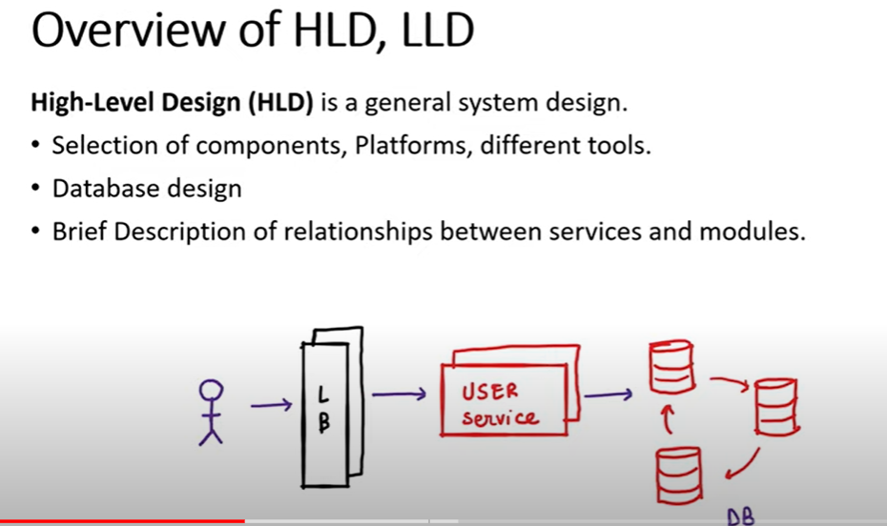

High level design with loadBalancer having userserver with crud operations.

Low Level Design for the Above Example.

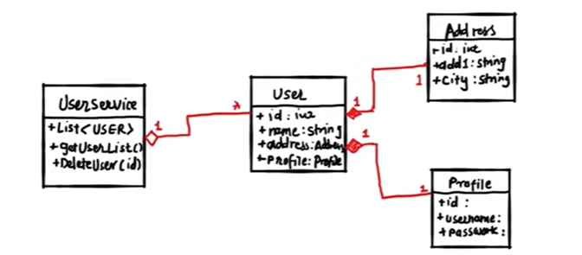

**HLD vs LLD**

| **High-Level Design** | **Low-Level Design** |
| --- | --- |
| HLD is a macro-level design or system design. It allows seeing the “Big Picture.” | LLD is a micro-level design or detailed design. It allows seeing the minutiae. |
| The overall architecture of the application and the network design as well as relationships between various system modules and functions. | A detailed description of each and every module that is mentioned in the high-level design (HLD.) |
| **Target audience:**clients, designers, reviewers, management team members, program and solution teams. | **Target audience:** designer teams, operation teams, and implementers. |
| **Main idea:**HLD is required to understand the flow across various system entities. For example, if you have several integrated solutions, HLD describes how everything works as a single organism. | **Main idea:**provides information for building the product, its configuration, and troubleshooting. For example, if you have several solutions, LLD describes each one in detail, like a single organ in a body. |
| **Goal:** converts business goals and requirements into a high-level solution. | **Goal:** converts a high-level solution into a detailed solution ready for building. |
| **Chronologically,**HLD is created before any other technical documentation. | **Chronologically,** LLD is created after the high-level design document. |
| **HLD Creator:**Solutions Architect. | **LLD Creator:**Designers & Developers with PM. |
| **Input Data:**software requirement specifications (SRS.) | **Input Data:**reviewed and authorized high-level design document (HLD.) |
| **Results:** database design, functional design, and review record. | **Results:** program specification and unit test plan. |

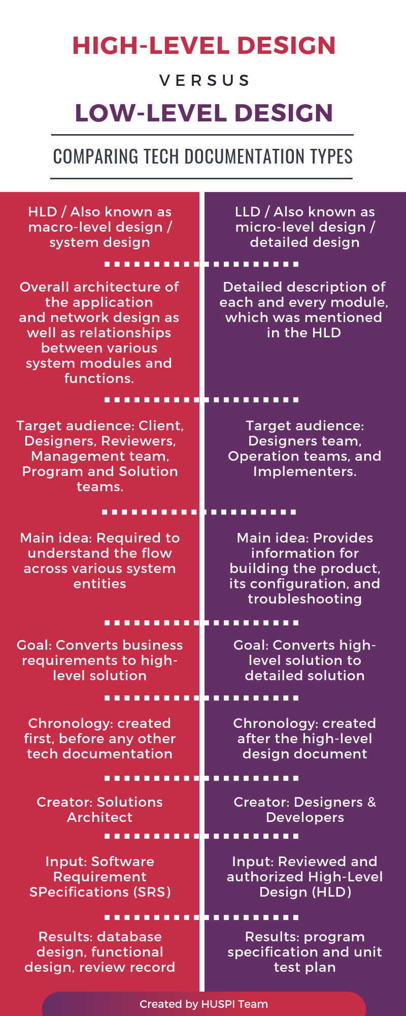

**Low Level Design :**

For low level design the input is always is from HLD.

From the high level design we pick the single component and the we design the LLD for those components.

